

LFF Vision: The Learning Forward Foundation will establish a sustainable stream of funding to develop leaders who empower educators to learn for student success.

LFF Mission: The Learning Forward Foundation, a non-profit charitable organization, raises money to provide scholarships and grants to support and empower educators from across the globe to design high quality teaching that results in growth and achievement for every student through professional learning.

DALE HAIR AFFILIATE DEVELOPMENT GRANT

The Learning Forward Foundation is making available one grant opportunity of up to $2,000 for one year to assist a Learning Forward affiliate needing to rebuild, reorganize, or generate a more vital organization. The grant will honor Dale Hair’s legacy of work with the affiliates and her passion for supporting the successful work of the affiliates.

Each grant is designed to help affiliates who need assistance, resources, and support in building, rebuilding, or strengthening the affiliate. A clear description of the current state of the affiliate is critical to help readers understand the affiliate’s need for the grant award. Applicants will agree to focus on leadership development and build internal board capacity within the affiliate aligned to the Learning Forward vision and mission statements. https://learningforward.org/about/vision-beliefs/

The Affiliate awarded this grant will develop and implement a one-year plan based on their identified needs that will:
- focus on developing knowledge and skills for a stronger affiliate board;
- support board members in deepening their learning on effective systems of professional learning and/or
- create structures to network within the state.
A successful grant will have a plan consisting of activities and steps for improvement of the affiliate board.

The Dale Hair Affiliate Grant is only available to officially recognized Learning Forward state, regional, provincial, or country affiliate organizations. See the Learning Forward Affiliate webpage https://learningforward.org/affiliates for more information about affiliates.

Directions: Complete all components of the grant application and send it electronically along with a letter of support to Nadine Butts nbutts60@gmail.com.
Grant Submission Deadline: March 20, 2026
Grant Award Announcement in May

SECTION I: APPLICANT INFORMATION
Fill in the Word document and send as an attachment to an email.

Applicant Name: _____________________________________________________________

Affiliate: ______________________________ Affiliate Position: _________________________

District/Organization: __________________________________________________________

Position: __________________________________________________________________

Street Address: _____________________________________________________________

City: _________________________ State/Province: _________ Zip/Postal Code: ___________

Telephone: ______________________ Email: _____________________________________
(work/home or cell)
Learning Forward Member Number _________________ How many years? _________________
All Learning Forward Foundation awardees will require a Learning Forward membership to activate the grant.

SECTION II: OVERVIEW OF PROJECT
In 75 words or less, describe your plan in terms of a problem/challenge or dilemma for your affiliate that you intend to address.

SECTION III: PROPOSAL
Background thinking for you and your affiliate as you write your proposal:
Consider the questions below as you write your proposal. In addition, take time to examine the rubric that will be used for scoring. This proposal requires a comprehensive, written answer to each of the ten questions in Section III; completion of the Action Plan Template in Section IV, the Budget Template in Section V, the Statement of Commitment in Section VII, and the Completed Application Information in Section VIII.

Proposal readers will evaluate this proposal by referring to the rubric and analyzing the package materials.

Please review the Learning Forward Standards https://standards.learningforward.org/ before beginning your application.

Complete the following questions:
- Which of the following most closely describes your affiliate's current state? Indicate here (a, b, or c):
  - Emerging as a new, first-time affiliate
  - Re-emerging (possibly with some new leadership) as an “active” affiliate after a period of being “inactive”
  - Seeking to rebuild, reorganize, or reconstitute the current affiliate, which is struggling

- What two or three outcomes will you achieve with this grant for your affiliate?

- Describe your current challenges or struggles as an emerging or rebuilding affiliate.

- What actions will you take to overcome your current challenges and accomplish these outcomes?

- How does your plan of action align with Learning Forward’s and Learning Forward Foundation’s vision and mission? (Be specific)

- How will your current leadership team or affiliate board members be involved in reaching these outcomes?

- How will this grant build the capacity of the leadership team or board members to continue and sustain the work of the affiliate and align itself to the vision, mission, and strategic goals of Learning Forward?

- What evidence will you collect to show you are making progress toward your outcomes?

- How will you monitor and adjust your action plan based on the evidence you collect?

- How will the funds from this grant support your action plan and foster your affiliate’s financial stability?

SECTION IV: ACTION PLAN TEMPLATE
(These should be stated in a specific, behavioral format. Example: As a result of this grant, board meetings will be transformed into professional learning experiences, with 70% being facilitated by our own staff.)
As a result of this grant, mentoring practices will be transformed into professional learning experiences facilitated 100% by our own staff.

Outcomes | ACTION  (What?) | TIMELINE  (When complete?) | PERSON  RESPONSIBLE  (Who?) | RESOURCES  NEEDED | RESULTS  ANTICIPATED
 | Ex.: Form study group to study job embedded professional learning | Ex.: Jan.-June 2024 | Ex.: Jose Alvarez | Ex.: Books for each participant | Ex.: Understand and plan effective  professional learning
SECTION V: BUDGET TEMPLATE
Include a snapshot of projected expenditures for the proposed work, up to $2,000.

Sample Budget Template | Cost
Registration for Summer Affiliate Meeting | $200
Travel for Summer Affiliate Meeting | $300
Consultant fees for board retreat | $500
Board development activities | $500
Supplies | $150
Location rental for member event | $350
Total Project Costs | $2,000

SECTION VI: LETTERS OF SUPPORT
A signed letter of support from the affiliate’s president, executive director, or leadership team must accompany the application. The letter should indicate the affiliate endorses the proposal by stating how it supports the applicant’s continuous improvement efforts; it must provide evidence this project is part of the affiliate board’s plan and assurances it will help fiscally support travel and lodging expenses for Learning Forward Annual Conference.

SECTION VII: STATEMENT OF COMMITMENT
Purpose: This document describes the responsibilities and obligations of the applicant for the Learning Forward Foundation Affiliate Grant. Please indicate your acceptance of these responsibilities by signing the document at the end. Successful affiliates will sign a memorandum of understanding with the Learning Forward Foundation that reflects these commitments.

Responsibilities:
The affiliate will:
- Complete all activities listed in this application unless permission to alter the activities is requested, with a rationale for the change, and permission is granted by the Learning Forward Foundation.
- Provide a written evaluation of the activities and the overall grant impact (attainment of outcomes, or progress made).
- Complete a reflective analysis of lessons learned from the implementation of this grant and how those insights will inform the next steps for the affiliate, including how your affiliate will impact standards-based professional learning going forward.
- Send an email to Dale Hair upon award of the grant to share the affiliate’s plans and to share their appreciation of her support.

The project leader will:
- Commit to an active role as a learner throughout the period of the grant.
- Provide an interim progress update on the implementation of the action plan.
- Maintain regular communication with the grant representative from the Learning Forward Foundation.
- Share final outcomes and lessons learned from the grant with the Foundation and affiliate leaders. This may include a report during the Summer Affiliate Leaders Meeting or sharing via conference calls or webinars.
- Participate in one touch-point conversation annually with members of the Research and Support Committee and the grant lead.

SECTION VIII: COMPLETED APPLICATIONS
Submit all application materials electronically. Send completed Word documents as attachments to email messages. Be sure to include your last name in any electronic file names.

Placement of your name on the signature line of this application constitutes your signature and commitment to these statements.

Name of Applicant ______________________________________________________

Title/Role in Affiliate _____________________________________________________

Signature ________________________________________ Date ________________
Directions: Complete all required sections of the application. Submit Sections with the letter of support electronically to Nadine Butts nbutts60@gmail.com. If you do not receive confirmation of receipt of materials within five days, contact Niki Gamble at niki@learningforward.org.

Nadine Butts
Vice-Chair, Scholarships and Grants
Learning Forward Foundation
nbutts60@gmail.com

SECTION IX: RUBRIC OUTLINE
Note: This is for reference only. Use this rubric to guide your writing.
Do not include this document in your application.

Clear and Complete Document Criteria | Y/N
Application complete, including contact information, proposal, action plan, budget template and signed statement of commitment.
Separate letter of support

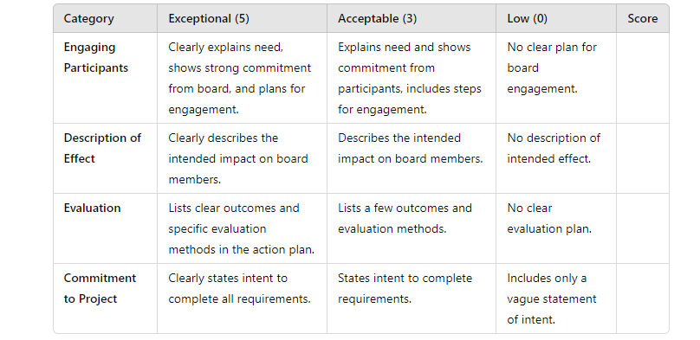
This scale ranges from 0-5

