Monday, December 3 8:30 a.m. – 11:30 a.m.
1320 | Walking the Talk of Educational Transformation
Engage with a story of educational transformation - informed by the knowledge of teachers, students and community; grounded in the wisdom of indigenous people; weaving together a global education conversation, an empowering curriculum, and learning sciences. Explore the role that school and district leadership play. Leave with frameworks and processes to apply in your context.
Denise Augustine, SD79 Cowichan, Rod Allen, School District 79 Cowichan Valley

1322 | Building Collective Efficacy Through Collaborative Response to Intervention
Learn how to use conversations about students as a mechanism to enhance teacher instructional capacity and maximize distributed coaching. Examine the essential elements of the Collaborative Response Model--an Alberta-born framework--that values purposeful collaboration, action-focused responses, data-informed discussions, and timely intervention to ensure all students can experience success. Leave with next steps to establish a framework of responsiveness for identified school or district priorities.
Kurtis Hewson, Lorna Hewson, Jigsaw Learning

Monday, December 3 9:30 a.m. – 11:30 a.m.
1204 | Today's Students- Tomorrow's STEM Leaders
Explore the instructional pedagogies needed to transform your classroom into an innovative, engaging STEM environment. Learn to support students through engaging them in higher order thinking, inquiry-based problem solving and the engineering design process. Create inquiry-based STEM instruction that encourages learners to think critically and have a high level of STEM proficiency. Leave with several classroom-ready resources and a better understanding of how to draw from existing assets such as literacy-based strategies to inform STEM-focused learning and instruction.
Fouada Hamzeh, Clara Howitt, Greater Essex County District School Board

1219 | Collaboration and Leadership: Strengthening Equity, Well-being, and Achievement
Learn about the concept, components, and benefits of collaborative leadership based on the theory of Leading from the Middle for organizations, districts, schools, educators and students. Explore the potential of inter-district collaboration and its impact on staff and student learning and leading Understand the results of critical inquiry relating to collaborative leadership and its impact on building equity, well-being, and achievement as described in the 2018 research study conducted by Hargreaves and Shirley. Explore the power and possibilities of collaborative leadership in your system or school.
Michelle Forge, Michael O'Keefe, Council of Ontario Directors of Education

Monday, December 3 2:30 p.m. – 3:30 p.m.
TL18 | British Columbia's Learning Transformation: A Glimpse of the Future?
What happens when you connect students, teachers, parents, post-secondary, and business to co-construct the future of learning? Find out why British Columbia, already a top-performing jurisdiction, felt they needed to embark on such an ambitious transformation process. What lessons can we learn? What are the professional learning implications for the K-12 system, university admissions including teacher pre-service, and other stakeholders?
Rod Allen, Cowichan Valley School District, Leyton Schnellert, University of British Columbia

Monday, December 3 2:30 p.m. – 4:30 p.m.
1436 | Changing Conversations: Push, Pull, Nudge Towards Collaborative Professionalism
Learn how to set conditions to support changed teaching/assessment practices through effective learning communities. Examine how school leaders select effective resources, communicate, and use facilitation skills to leverage relationships/interpersonal skills to impact deep learning for students and faculty. Learn to use global competencies (i.e. collaboration, critical thinking, innovation and creativity) to spark teacher engagement in their own deep learning and support 21st Century learning for their students. Leave with strategies to support learning for school leaders and faculty that impact positive student achievement.
Kim Jensen, Thelma Sambrook, Toronto District School Board

Tuesday, December 4 7:30 a.m. – 8:00 a.m. OR 8:00 a.m. – 8:30 a.m.
RT07 | Parent Leadership in Our School Community
Engaging with active, happy parents at school can be an amazing experience for both families and teaching staff. How can we encourage parents to have be active involvement in a school community? Attend this session to explore ways to increase parents' enthusiasm and excitement about volunteering in the school community. Learn with other participants how to create a responsible, motivated parent leader who will encourage others to succeed. Invite your parents to become involved with the school to support
learning for all students.
Sarah Shakespeare, Central Okanagan SD

TC01 | Making Sense of Data Using Pre-Built Analytic Dashboards
Learning how to use a library of analytic visuals will give educators, especially school administrators, tools they can use to make sense of data collected at the school-, department- or teacher level. Join this session to construct dashboards that let users analyze what is happening in classrooms; make learning visible by viewing standards alignment, evidence of student learning, failure rates, and depth of knowledge. Use data to address needs of student subgroups as well as to monitor compliance, growth, and reward teacher improvement.
Paul Shuster, Ottawa Carleton District School Board (Retired)

Tuesday, December 4 8:30 a.m. – 11:30 a.m.
2305 | Developing Equity-Minded Mentors to Inspire Novice Teachers
Learn how a district intentionally designs opportunities to nurture school-based mentor-leaders as reflective, equity-minded practitioners, meeting the academic and social needs of learners and inspiring novice teachers. Investigate a replicable model of collaborative inquiry, guided reflection and digital documentation of learning to uncover personal bias and deepen understanding of culturally responsive practices. Examine how the design of professional learning affects mentors’ mindsets and professional practice to support novice teacher efficacy.
Allison Cunningham, Hiren Mistry, Peel District School Board

Tuesday, December 4 9:30 a.m. – 11:30 a.m.
2229 | Improving At-Risk Student Achievement by Monitoring our Evidence
Learn how the Monitoring Our Evidence protocol empowers educators to make effective teaching decisions that are timely and relevant and make a positive impact on student outcomes. The strength of this continuous feedback model is its ability to change teacher practice as it focuses on both student and teacher metacognition. Understanding the effective methods for gathering evidence of thinking. See how this continuous cycle of collaboration and data collection creates a culture of learning.
Beth Zimmerman, Linda Ruitenbeek, Thames Valley District School Board
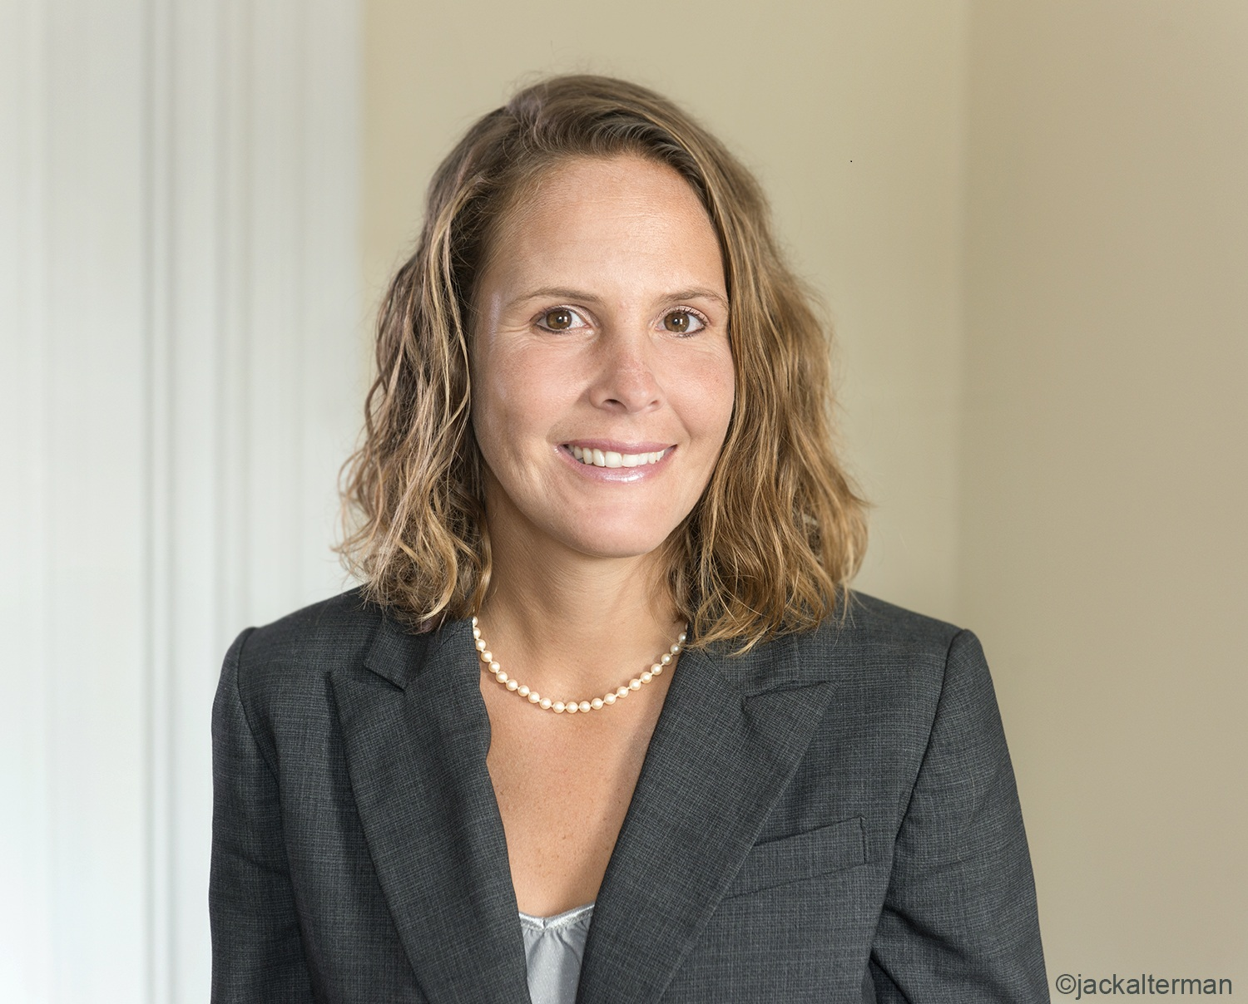
Tuesday, December 4 10:30 a.m. – 11:30 a.m.
TL26 | Social and Emotional Learning in Research and Practice
What are the features and best practices of effective social and emotional learning programs? How can they be planned and carried out well, both in school and out-of-school settings? Researchers from Harvard’s EASEL Lab discuss the recommendations in the publication Preparing for Effective SEL Implementation, supported by The Wallace Foundation. Explore how to ensure sufficient staff support and approaches to dealing with logistical and budget challenges.
Katie Brush, Harvard's EASEL Lab, Bridget Laird, WINGS for Kids

Tuesday, December 4 3:30 p.m. – 5:30 p.m.
2440 | How School Leaders Support Literacy Achievement in PLCs
Learn how a leadership and a literacy coach have teamed together to provide tangible support for a school implementing the professional learning community process. Participate in literacy instructional practices, review common formative assessments, and consider ways for discussing evidence that align to priority standards and learning targets. Recognize how principals can support teams and what they can expect to see in classrooms that engage meaningfully in literacy instruction.
Kathy Glass, Glass Educational Consulting, Karen Power, East Coast Education Leaders Inc.

Wednesday, December 5 7:45 a.m. – 10:45 a.m.
3311 | SPDU Provincial Facilitator Community: An Empowerment Model
Explore the systems and structures of the Saskatchewan Provincial Facilitator Community, an innovative capacity-building model of professional learning developed by the Saskatchewan Teachers' Federation. Examine your system readiness to implement portions of this model by assessing organizational mindset and existing infrastructure to determine possible next steps that fit your context. Participants will learn about structures including professional learning supports for community members, monitoring and mentorship processes used, work plan development and organizational oversight.
Terry Johanson, Lindsay Shaw, Saskatchewan Teachers' Federation

Wednesday, December 5 8:45 a.m. – 10:45 a.m.
3204 | Insight: Professional Learning for Meta-Cognitive Teaching
Explore the role of insight in addressing the question, “What does engaged learning look like?” Connect with Hattie’s research on Visible Learning and Mindframes to address the problem of assessing positive impacts on student learning. Discover a model of collaborative professional learning that can help you learn how to maximize the occurrence of insight for students and improve student results.
Alexandra Gillis, Ministry of Education, David Wilkie, SD39 Vancouver School Board

3222 | Becoming a Learning Team (repeated as 3420)
While many schools use PLCs or other collaborative structures for teacher learning, little information is available that attends to exactly what happens during that collaborative time. With a focus on the day-to-day actions in classrooms between students, educators, and instructional materials, this session will provide an overview of a five-stage teacher team learning cycle and is based on Learning Forward’s recent updated book Becoming a Learning Team. Explore steps teacher teams can take toward intentional, collaborative professional learning. Learn about one school’s application of the cycle and lessons learned along the way.
Clara Howitt, Alexandra Fuentes, Learning Forward

Wednesday, December 5 1:00 p.m. – 3:00 p.m.
3420 | Becoming a Learning Team (repeat of 3222)
While many schools use PLCs or other collaborative structures for teacher learning, little information is available that attends to exactly what happens during that collaborative time. With a focus on the day-to-day actions in classrooms between students, educators, and instructional materials, this session will provide an overview of a five-stage teacher team learning cycle and is based on Learning Forward’s recent updated book Becoming a Learning Team. Explore steps teacher teams can take toward intentional, collaborative professional learning. Learn about one school’s application of the cycle and lessons learned along the way.
Alexandra Fuentes, Learning Forward, Clara Howitt, Greater Essex District School Board

Please see conference.learningforward.org/program for a complete program and lfp.learningforward.org/session-selection/find-a-session.cfm for additional sessions from
Canada.

