How to promote the Learning Forward

2018 Annual Conference

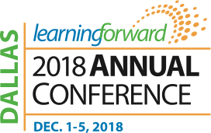

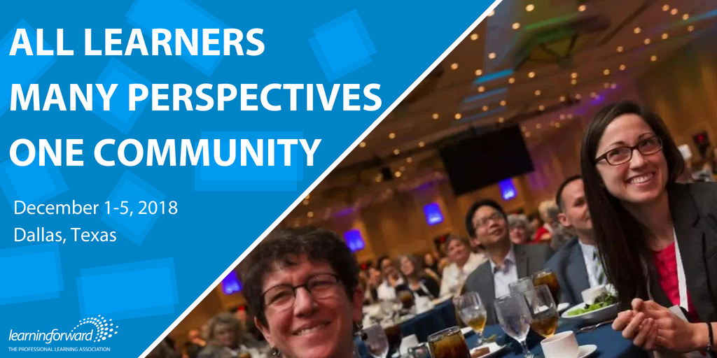

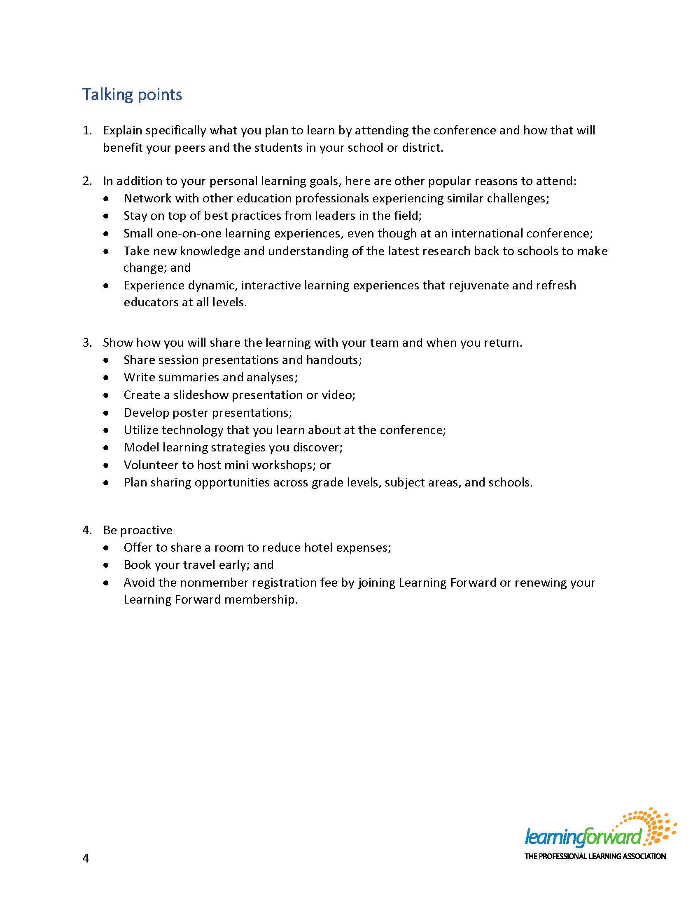

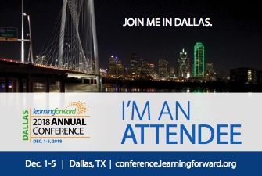

Each year, Learning Forward creates a promotional kit that allows members, affiliates, event attendees, and sponsors to easily share and promote the Annual Conference using pre-designed materials. We hope that you will help spread the word about this year’s Annual Conference by using the tips and materials in the kit. Thank you for helping us build a great conference. See you in Dallas!

**Where is the promotional kit?**

conference.learningforward.org/promo

**What is included in the promotional kit:**

* Conference details, including the hashtag, URL, location, dates, and the theme of the conference.
* Short and long text descriptions of conference to be used for newsletters, emails, web pages, etc.
* Banner ads
* Social media shareable images
* Pre-populated tweets (social posts)
* Promotional video
* Conference graphics (ex: Conference logo)
* Social badges (ex: “I’m an attendee. Join me in Dallas”)
* Justify your attendance kit
* And more.