Justify Your Attendance Kit for Learning Forward’s 2018 Annual Conference

Macintosh HD:Users:Anthony:Dropbox (LEARNING FORWARD):Communications Team:Branding:Logo:LearningForward_tag logo.eps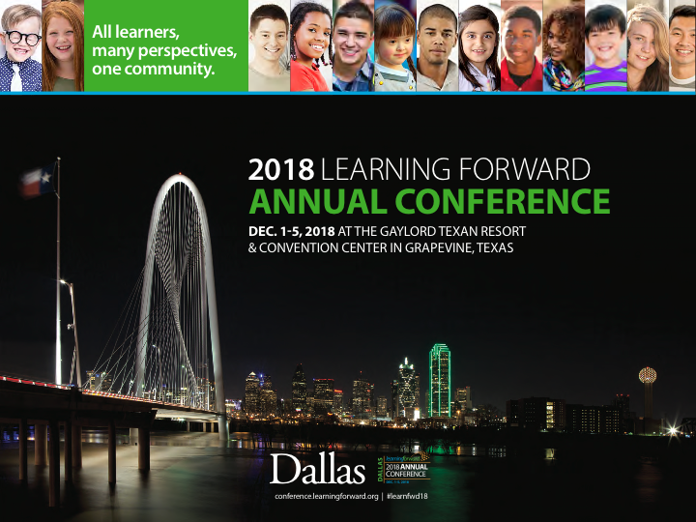

Table of Contents

[Talking points 3](#_Toc519668980)

[Sample letter: Request for approval 4](#_Toc519668981)

[Topics covered 5](#_Toc519668982)

[Benefits to district 6](#_Toc519669005)

[Who attends 6](#_Toc519669006)

[Pricing 7](#_Toc519669007)

[Alternative funding options 8](#_Toc519669010)

[***Learning First Alliance letter* \_\_\_\_\_\_\_\_\_\_\_\_\_\_\_\_\_\_\_\_\_\_\_\_\_\_\_\_\_\_\_\_\_\_\_\_\_\_\_\_\_\_\_\_\_\_\_\_\_\_\_\_ *9***](#First_alliance_letter)

# Macintosh HD:Users:Anthony:Dropbox (LEARNING FORWARD):Communications Team:Branding:Logo:LearningForward_tag logo.epsTalking points

1. Explain specifically what you plan to learn by attending the conference and how that will benefit your peers and the students in your school or district.
2. In addition to your personal learning goals, here are other popular reasons to attend:

* Network with other education professionals experiencing similar challenges;
* Stay on top of best practices from leaders in the field;
* Small one-on-one learning experiences, even though at an international conference;
* Take new knowledge and understanding of the latest research back to schools to make change; and
* Experience dynamic, interactive learning experiences that rejuvenate and refresh educators at all levels.

1. Show how you will share the learning with your team and when you return.

* Share session presentations and handouts;
* Write summaries and analyses;
* Create a slideshow presentation or video;
* Develop poster presentations;
* Utilize technology that you learn about at the conference;
* Model learning strategies you discover;
* Volunteer to host mini workshops; or
* Plan sharing opportunities across grade levels, subject areas, and schools.

1. Be proactive

* Offer to share a room to reduce hotel expenses;
* Book your travel early; and
* Avoid the nonmember registration fee by [joining Learning Forward](https://learningforward.org/join-renew) or renewing your Learning Forward membership.

# Sample letter: Request for approval

##### Dear Colleague,

##### I am writing to request approval to attend the Learning Forward Annual Conference this December 1-5.

##### [Explain specifically what you plan to learn by attending the conference and how that will benefit your peers and the students in your school or district.]

##### *Example: As you know, our professional learning goals this year include developing personalized instruction and data-based program evaluation. Learning Forward’s conference is the only place where I can easily attend more than 12 sessions on just these two topics, plus more than* [*300 sessions*](https://myconference.learningforward.org/annual17/sessions/find-a-session.cfm) *focused on other areas of need.*

##### Here are some other advantages to attending this conference:

##### Networking with other educators who are experiencing similar challenges;

##### Staying on top of best practices from leaders in the field;

##### Seeing first-hand the kinds of dynamic, interactive learning experiences that rejuvenate and refresh educators at all levels.

##### [Describe how you plan to share the learning upon your return.]

##### *Upon my return, I plan to share my learning with my team and other staff as needed. I can do so by sharing session presentations, handouts, and written summaries. I can also utilize technology that I learn about, model learning strategies I discover, and host mini workshops across grade levels, subject areas, and schools.*

##### The cost of the conference ranges from $175 - $235 per day and includes lunches. Right now, the cost to fly is only \_\_\_\_\_. Including hotel, I estimate the total cost to be \_\_\_\_\_\_. I can save on costs by booking my travel early and registering with the early members-only rates, so I look forward to your response.

##### Thank you,

##### [name]

# Topics covered

★★Adult development and learning

Advocacy Efforts / Policy Development

★★Allocatingtime and dollars for professional learning

Blended/Online Learning

★Career pathways

★★ChangeManagement

Charter Schools/Networks

Coaching Practices/Programs

Collaborative inquiry

College- and career-readiness/student performance standards

Community/Family Engagement

★Comprehensive System Improvement/Reform

Continuous improvement Cycles

Cultural/Gender/Racial Equity

★Culturally responsive pedagogy

Culture and climate

Data-driven decision making

Deeper Learning

★★Distributed/Shared Leadership

Early Childhood

Educator Effectiveness

★Engaging/Motivating Disenfranchised Learners

★English Learners / Linguistic Diversity

Equitable Outcomes

★ESSA - Every Student Succeeds Act

★Evaluation and Impact

★Facilitation and Presentation Skills

★Feedback and Observations

★Formative Assessment Practices

Future-ready learning

★★Global Perspectives and Learning

Improvement Science

Improving Instruction

★Induction and Mentoring

★Instructional leadership and supervision

Instructional Rounds / Walk-Throughs

Integrating student or teacher voice

★Leadership Development

★Learning Networks

Literacy

Mathematics

★Measuring impact

★Micro-Credentials / Badging

★Models of Professional Learning

★Open Educational Resources/Practices (OER/OEP)

★Partnerships and coalition building

★★Personalized Learning (Educators and Students)

★★Policy Development and Advocacy

★★Principal Pathways/Pipelines

Rural issues and settings

School Improvement/Reform

Science

Social Emotional Learning/Health (SEL/SEH)

STEM: Science, technology, engineering, and math

★★Teacher Pathways/Pipelines

★Technology for professional learning

Technology to enhance student learning

★★Title I / Economically disadvantagedpopulation

Urban issues and settings

(★=popular, ★★=Hot)

# Benefits to district

Effective professional learning remains the single most powerful investment a district can make for improving educator effectiveness to increase student achievement.

The conference offers a district’s education leaders

* Connections;
* Tools;
* Learning opportunities; and
* Resources needed to design, implement, and measure high-quality professional learning for educator and student success.

# Who attends

**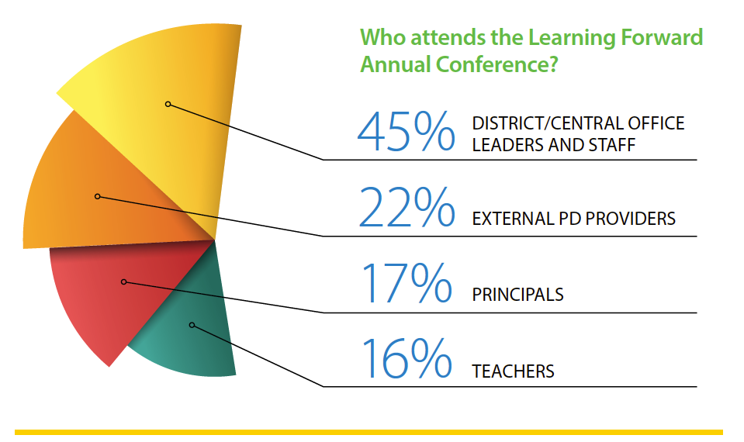**

# Early Bird Registration (May 1 through July 31, 2018)

| **Dates** | **Member** | **Non- Member** |
| --- | --- | --- |
| Saturday, Dec. 1 | $210 | $230 |
| Sunday, Dec. 2 | $210 | $230 |
| Monday, Dec. 3 | $210 | $230 |
| Tuesday, Dec. 4 | $185 | $210 |
| Wednesday, Dec. 5 | $175 | $200 |

# Early Registration (August 1 through October 31, 2018)

| **Dates** | **Member** | **Non-Member** |
| --- | --- | --- |
| Saturday, Dec. 1 | $225 | $245 |
| Sunday, Dec. 2 | $225 | $245 |
| Monday, Dec. 3 | $225 | $245 |
| Tuesday, Dec. 4 | $200 | $225 |
| Wednesday, Dec. 5 | $190 | $215 |

# Regular & Onsite Registration (November 1 through December 5, 2018)

| **Dates** | **Member** | **Non-member** |
| --- | --- | --- |
| Saturday, Dec. 1 | $235 | $255 |
| Sunday, Dec. 2 | $235 | $255 |
| Monday, Dec. 3 | $235 | $255 |
| Tuesday, Dec. 4 | $210 | $235 |
| Wednesday, Dec. 5 | $200 | $225 |

# Alternative funding options

Seek out grants from organizations you belong to, including state or provincial education agencies, PTA/PTO, religious institutions, Kiwanis or Rotary Clubs, etc.­­­­­­

Here are some organizations to help find grants:

* The Grants.gov program management office was established, in 2002, as a part of the President's Management Agenda. Managed by the Department of Health and Human Services, Grants.gov is an E-Government initiative operating under the governance of the Office of Management and Budget. [https://www.grants.gov](https://www.grants.gov/)
* GrantSelect is an online database of funding opportunities such as grants (for programs, projects, planning, start-up, endowments, technical assistance, facilities and equipment, etc.), awards, and fellowships for example. https://www.grantselect.com
* Dedicated GrantWatch researchers and grant associates, publish the newest grants and letters of inquiry (daily) and archive the grants with past funding dates.  Government agencies, foundations, and corporations post the details of their funding opportunity for free through their dedicated portal. <https://www.grantwatch.com/grant-search.php>
* ENGLISH LANGUAGE ACQUISITION STATE GRANTS <http://www2.ed.gov/programs/sfgp/index.html?exp=0>
* The Teacher Quality Partnership (TQP) grant program, authorized in Title II of the Higher Education Act, is the only federal initiative designed to strengthen and reform educator preparation at institutions of higher education. <https://aacte.org/policy-and-advocacy/federal-policy-and-legislation/435-teacher-quality-partnership-grants>
* Special Education -- State Personnel Development Grants Program <https://www2.ed.gov/programs/osepsig/index.html>
* Special Education--Personnel Development to Improve Services and Results for Children with Disabilities <https://www2.ed.gov/programs/osepprep/index.html>

