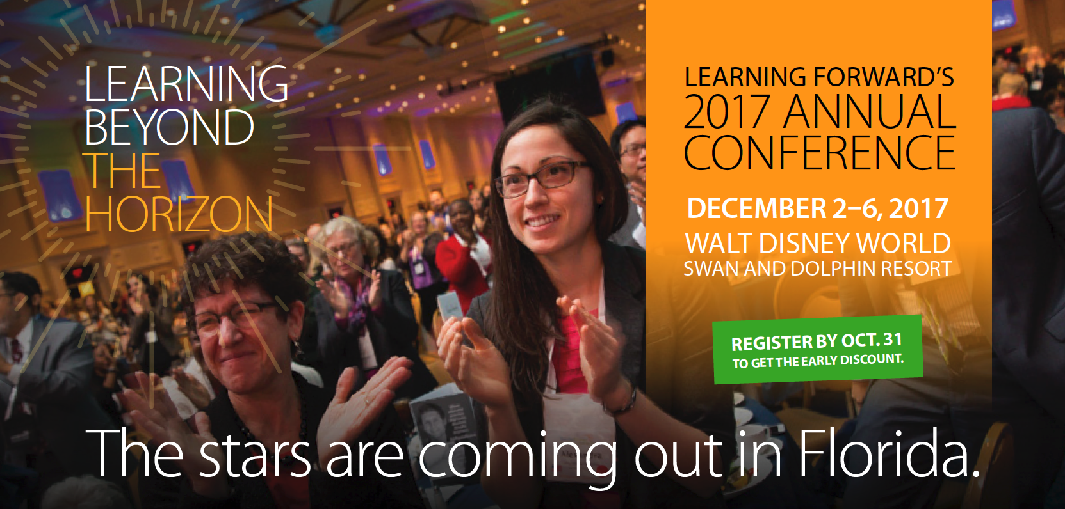Justify your attendance kit for Learning Forward’s conference

Table of Contents

Sample letter: Request for approval 2

Talking points 3

Topics covered 4

Role-specific tracks 5

Benefits to district 5

Who attends 6

Early Registration pricing 6

Alternative funding options 6

Schedule at a glance 7

# Macintosh HD:Users:Anthony:Dropbox (LEARNING FORWARD):Communications Team:Branding:Logo:LearningForward_tag logo.epsSample letter: Request for approval

##### Dear Colleague,

##### I am writing to request approval to attend the Learning Forward Annual Conference this December 2-6.

##### [*Explain specifically what you plan to learn by attending the conference and how that will benefit your peers and the students in your school or district.*]Example: As you know, our professional learning goals include developing personalized instruction and data-based program evaluation. Learning Forward’s conference is the only place where I can easily attend more than 12 sessions on just these two topics, plus more than [300 sessions](https://myconference.learningforward.org/annual17/sessions/find-a-session.cfm) focused on other areas of need.

##### Here are some other advantages to attending this conference:

##### Networking with other education experiencing similar challenges;

##### Staying on top of best practices from leaders in the field;

##### Seeing first-hand the kinds of dynamic, interactive learning experiences that rejuvenate and refresh educators at all levels.

##### Upon my return, I plan to share my learning with my team and other staff as needed. I can do so by sharing session presentations, handouts, and written summaries. I can also utilize technology that I learn about, model learning strategies I discover, and host mini workshops across grade levels, subject areas, and schools.

##### The cost of the conference is approximately $190 per day and includes lunches and some breakfasts. Right now, the cost to fly is only \_\_\_\_\_. Including hotel, I estimate the total cost to be \_\_\_\_\_\_. I can save on costs by booking my travel early and registering with the members-only rates, so I look forward to your response.

##### Thank you,

##### [name]

# Talking points

1. Explain specifically what you plan to learn by attending the conference and how that will benefit your peers and the students in your school or district.
2. In addition to your personal learning goals, here are other popular reasons to attend:

* Network with other education professionals experiencing similar challenges;
* Stay on top of best practices from leaders in the field;
* Small one-on-one learning experiences, even though at an international conference;
* Take new knowledge and understanding of the latest research back to schools to make change; and
* Experience dynamic, interactive learning experiences that rejuvenate and refresh educators at all levels.

1. Show how you will share the learning with your team and when you return.

* Share session presentations and handouts;
* Write summaries and analyses;
* Create a slideshow presentation or video;
* Develop poster presentations;
* Utilize technology that you learn about at the conference;
* Model learning strategies you discover;
* Volunteer to host mini workshops; or
* Plan sharing opportunities across grade levels, subject areas, and schools.

1. Be proactive

* Offer to share a room to reduce hotel expenses;
* Book your travel early; and
* Avoid the nonmember registration fee by [joining Learning Forward](https://learningforward.org/join-renew) or renewing your Learning Forward membership.

# Macintosh HD:Users:Anthony:Dropbox (LEARNING FORWARD):Communications Team:Branding:Logo:LearningForward_tag logo.epsTopics covered

**Areas of focus**

Learning Communities

Leadership

Resources

Data

Learning Designs

Implementation

Outcomes – Educator and Student Learning

Technology

Equity

Global / Emerging Issues

**Other topics**

Addressing change and resistance

Adult development and learning

Allocating resources for professional learning

Assessment and grading

Brain-based strategies

Career pathways

Coaching and school coaches

Collaborative inquiry

College- and career-readiness/student performance

Communities of Practice / Personal Learning Networks

Continuous improvement

Culturally responsive pedagogy

Culture and climate

Data-driven decision making

Differentiated instruction

Educator Effectiveness Measures

Equity

ESSA - Every Student Succeeds Act

Family and community engagement

Future-ready learning

Global perspectives

Instructional leadership and supervision

Integrating student or teacher voice

Leadership development and skills

Linguistic diversity/English language learners

Literacy

Mentoring and induction

Models of professional learning

Motivating/Engaging disenfranchised learners

Observation and feedback strategies

Online or blended learning

Other

Partnerships and coalition building

Policy development and advocacy efforts

Presentation and facilitation skills

Principal mentoring and/or coaching

Program evaluation

Project- or Challenge-based learning (PBL)

Response-to-Intervention

Rural issues and settings

School / System reform/improvement process

Social and emotional learning (SEL)

Social networking applications

Standards for Professional Learning Forward

STEM: Science, technology, engineering, and math

Teacher recruitment, support, development, and retention

Title I / Economically disadvantaged population

Urban issues and settings

Use of technology for professional learning

Use of technology to enhance student learning

Walk-throughs/Instructional Rounds

# 

# Macintosh HD:Users:Anthony:Dropbox (LEARNING FORWARD):Communications Team:Branding:Logo:LearningForward_tag logo.epsRole-specific tracks

Browse sessions by topic, set, presenter, and by audience. Choose the best sessions for your role, for instance:

* Sessions for [Superintendents](https://conference.learningforward.org/wp-content/uploads/sites/10/2017/10/learning-forward-2017-conference-superintendents-track.pdf)
* Sessions for [Academic Officers](https://conference.learningforward.org/wp-content/uploads/sites/10/2017/10/learning-forward-2017-conference-chief-academic-officers-track.pdf)
* Sessions for [Policymakers](https://conference.learningforward.org/wp-content/uploads/sites/10/2017/10/learning-forward-2017-conference-state-and-local-education-policymakers-track.pdf)
* Sessions for [Title I Schools](https://conference.learningforward.org/wp-content/uploads/sites/10/2017/10/learning-forward-2017-conference-educators-in-title-i-schools-track.pdf)

# Benefits to district

Effective professional learning remains the single most powerful investment a district can make for improving educator effectiveness to increase student achievement.

The conference offers a district’s education leaders

* Connections;
* Tools;
* Learning opportunities; and
* Resources needed to design, implement, and measure high-quality professional learning for educator and student success.

**Macintosh HD:Users:Anthony:Dropbox (LEARNING FORWARD):Communications Team:Branding:Logo:LearningForward_tag logo.eps**

# Who attends

**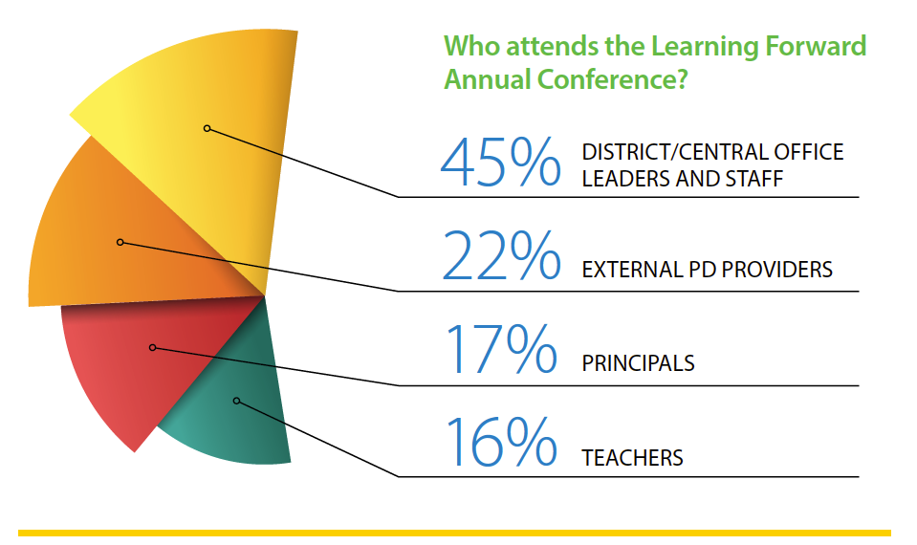**

# Macintosh HD:Users:Anthony:Dropbox (LEARNING FORWARD):Communications Team:Branding:Logo:LearningForward_tag logo.epsEarly Registration pricing

Dates Member Nonmember

Saturday, Dec. 2 $190 $202

Sunday, Dec. 3 $190 $202

Monday, Dec. 4 $185 $197

Tuesday, Dec. 5 $185 $197

Wednesday, Dec. 6 $185 $197

5-Day total $935 $995

*5-Day pricing increases by $50 on November 1, 2017*

# Alternative funding options

* The IRS offers a [$250 educator expense deduction](https://www.irs.gov/taxtopics/tc450/tc458) for out-of-pocket professional development costs.
* Seek out grants from organizations you belong to, including PTA, religious institutions, Kiwanis or Rotary Clubs, etc.

# Schedule at a glance

Macintosh HD:Users:Anthony:Dropbox (LEARNING FORWARD):Communications Team:Branding:Logo:LearningForward_tag logo.eps