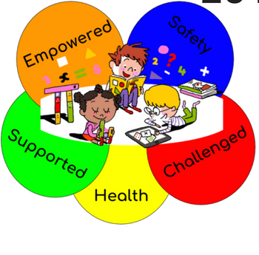

PERSONALIZED LEARNING:

EDUCATING THE WHOLE CHILD

Dr. Eric Mackey, State Superintendent

Keynote Speaker

## NOVEMBER 15-16, 2018

***LEARNING FORWARD ALABAMA ~ AN AFFILIATE OF LEARNING FORWARD***

SAVE THE DATE

28TH ANNUAL CONFERENCE

HYATT REGENCY

BIRMINGHAM, AL

WYNFREY HOTEL