6 Opportunities Preschoolers Need with Remote Learning

Heather Varon, M.Ed., CAEL

April 2021: Early Learning
214-478-0740
8417 La Fontaine
North Richland Hills, TX 76182

hvaron@esc11.net or heather_varon@yahoo.com

Early Childhood Campus Coach and Texas School Ready Coordinator/Coach
Education Service Center Region 11

Word Count: 1,797

The shutdown in March left many of us at home with small children while working. My daily work requires me to coach preschool teachers in childcare facilities and Head Start classrooms on best practices to help ensure their children are Kindergarten ready. I find it no small coincidence that my daughter was 3 years and 4 months at the time of the shutdown. While I was in the midst of working full-time giving advice to teachers, I was providing preschool to my daughter. This is not a practice I recommend, however, it did give me insight into what opportunities preschoolers need with remote learning. Much of what is true for face to face learning rings true for remote learning.
Opportunities for Experiences
Preschool age children need experiences, especially hands-on experiences. These experiences build background knowledge and help them develop language and vocabulary. Organize the experiences around a theme to give children the opportunity to develop new vocabulary and practice it in context in multiple areas. Young children with higher vocabulary development have a greater chance of having success in literacy development. Makes sense...more experiences...more words.
Experiences allow children to learn while playing. When children learn through play, they are more likely to remember the concepts. Some themes we learned through included butterflies, gardening, snow, camping, beach, gingerbread man, fairy tales, construction, veterinarian, and doctor. When possible we cooked together, and we baked lots of cookies. Her stuffed animals became patients for her vet clinic, and baby dolls became her patients for her doctor’s office. (Band-Aids do not come off fur easily.) We grew butterflies from caterpillars and carrots from seeds. Hearing a young learner use the word ‘chrysalis’ correctly is one of my favorite things about growing butterflies. Twice, believe it or not, in Texas we had snow, but, when we didn’t have the real stuff, we used instant snow. Magically, a box was turned into a castle and later a puppet stage. Characters from a snack box glued to sticks became puppets. A sheet transformed into a tent complete with a pretend campfire and cotton balls on sticks for roasted marshmallows.
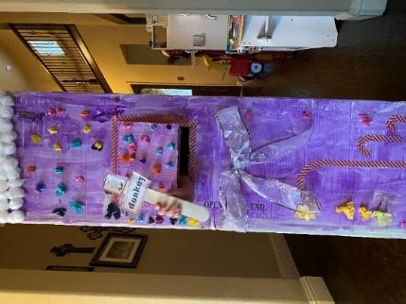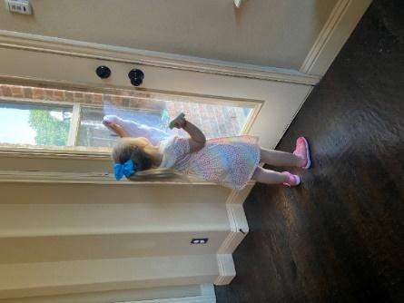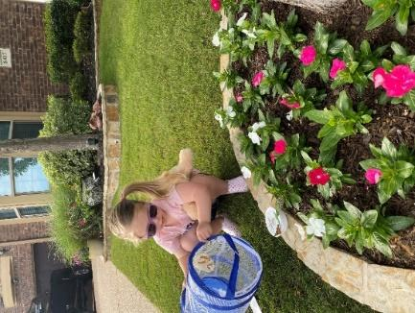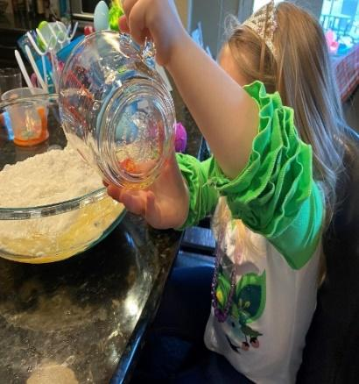
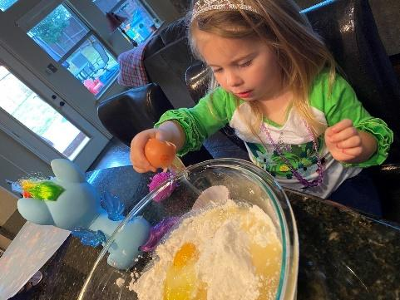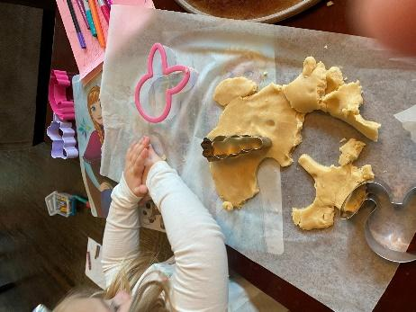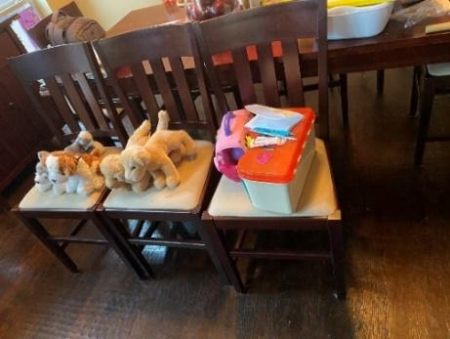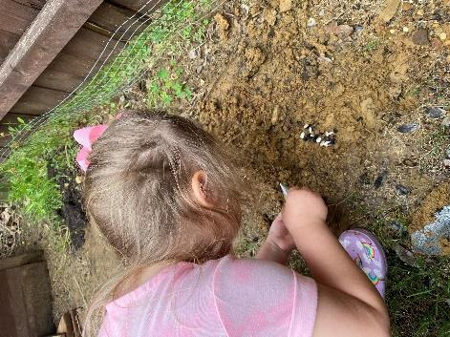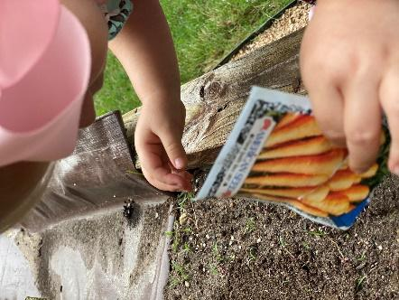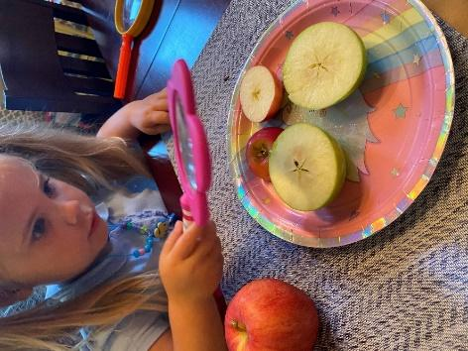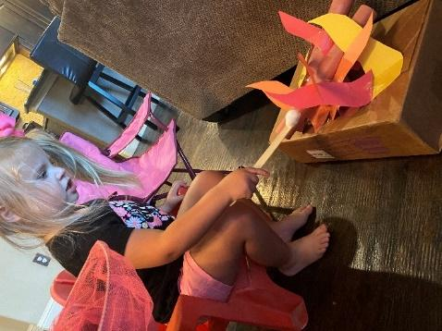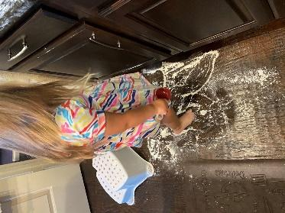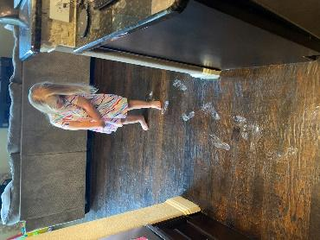
Throughout the days, my daughter sifted through dry beans, rice, and sand, kneaded homemade playdough and cookie dough, washed windows and hard toys, strung dry noodles and cereal, and squished Oobleck and cloud dough. Providing sensory activities like these activates many parts of the brain and promotes more complex learning while also developing fine motor skills to prepare their bodies for writing.
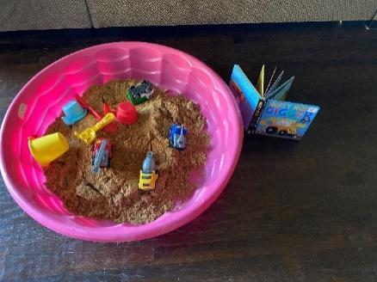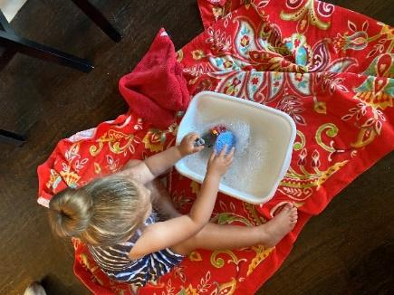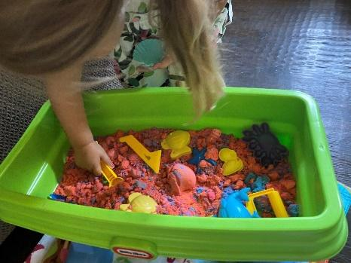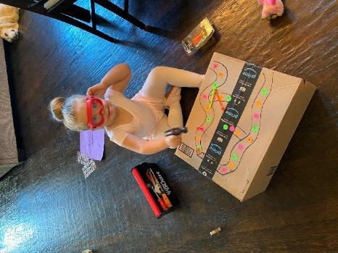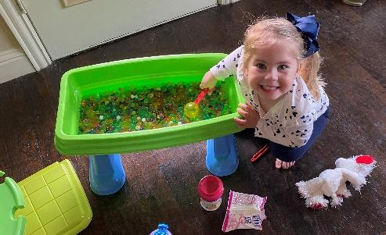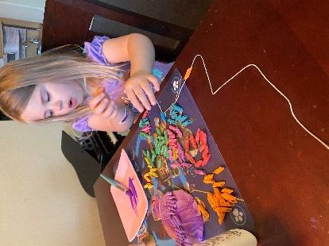
Instead of sending packets of worksheets home, consider sending thematic boxes easily prepped and packed with experiences for parents to provide their children while learning remotely.
These thematic hands-on experiences gave us common ground to talk about. At the end of the day, I always asked, “What was your favorite part of today?” We also reflected about all she had discovered through her play.
Each experience allowed for purposeful learning in playful ways.
Opportunities to Create
Opportunities to create are more about the process and not the product. Let preschoolers cut, paint, glue, and glitter. Glitter becomes a verb in the hands of a 4 year old.
We painted rocks, made bird feeders from pine cones, and crafted numerous unicorns from construction paper, pipe cleaners, and googly eyes.
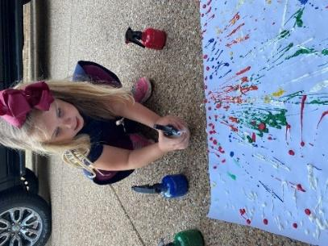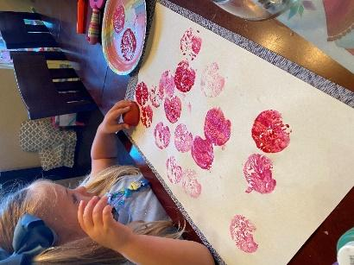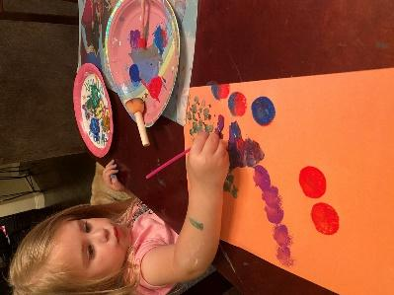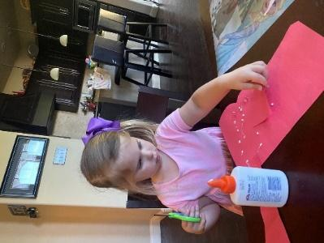
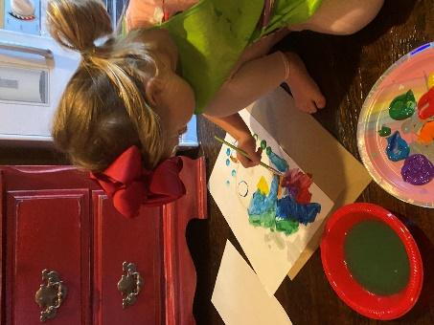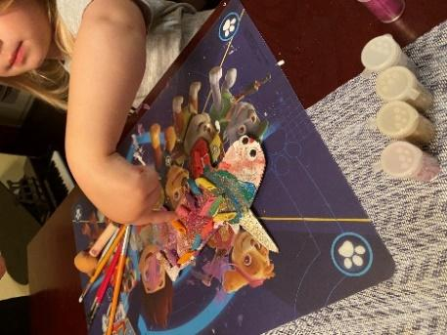
Fortunately we subscribe to a monthly craft box centered on a theme. Inside contains three different crafts for my daughter to make. Replicate this idea for your students who learn remotely. Fill a box with craft supplies; glue, scissors, paper, sequins, pom poms, popsicle sticks, and more. Local dollar stores and supermarkets have an abundance of craft supplies at low costs. I even purchased a craft container online filled with everything you would need to let your young artist create a masterpiece. It was amazing to see what all fit inside this thin cylinder. Think of the enjoyment parents and children will have crafting together.
As messy as it can be, let children enjoy the process of creating.
Opportunities to Read
Books, books, and more books!! We read a lot of books; including both fiction and nonfiction books tied to our theme to give even more exposure to vocabulary and content. Preschool children love to read the same book over and over again. Repeated readings promote early literacy skills. When a young child memorizes a book, it is a sign of early reading success.
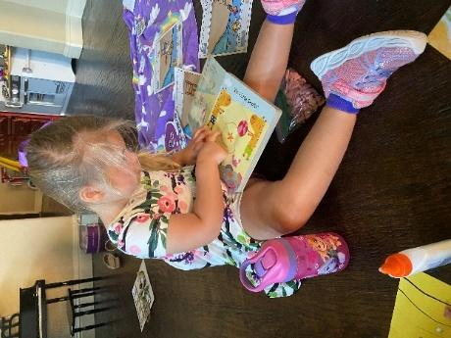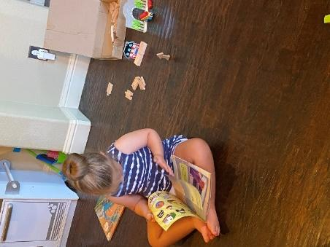
Enhance your readings by asking a few questions. Some examples are: What do you think will happen? Why did that happen? How does that character feel? Why do you think that?
Send books home with parents to read with their children. Encourage parents to use their local library or free libraries in their communities. Currently many picture books can be found being read on-line by their authors or a librarian. Access to books should not be a barrier.
Research has shown that the only way to become a reader or better reader is to surprisingly...read.
Opportunities to Write
Give children reasons to write and let them see you write. Show them grocery lists, to-do lists, thank you cards, orders at restaurants, and emails.
During vet or doctor visits, my daughter took serious notes on a notepad about each patient’s ailments. Because of social distancing, we wrote letters to friends and family, and my daughter was able to practice writing her name by signing at the end. Since I was at home working, she saw me on my computer quite a bit, so she also wanted to type. Often, she needed her work printed off to proudly display.
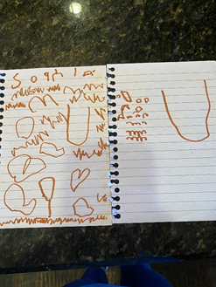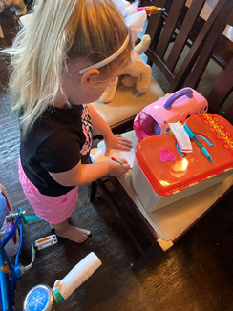
While functional writing is important in our everyday lives, composing stories helps children develop complex thinking skills. Provide children with blank books or blank paper stapled together in book format. Invite them to be authors like the ones who write the books they love. Use the hands-on experiences as springboards for book topics.
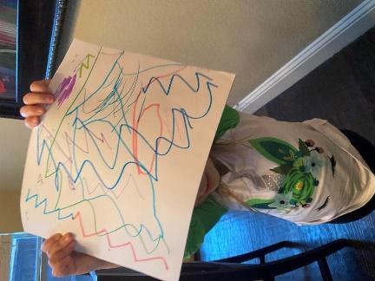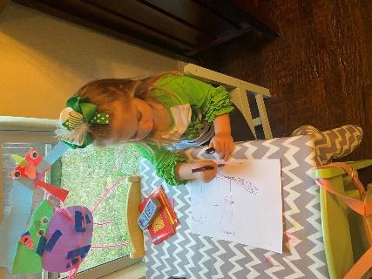
One afternoon, I took pictures of my daughter playing in the snow and glued the pictures to blank paper. I let her write a description on each page and tell me about what she wrote. At the time, she was in the very early stages of writing development, so it looks more like scribbling. Yet, when I asked her to tell me about what she wrote, she gave me a descriptive detailing of our day. That is what early writing is all about. We want children to see themselves as writers.
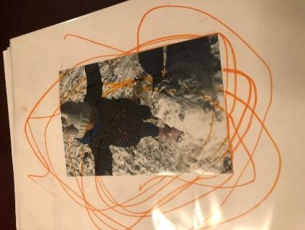
Send home writing materials such as blank paper, blank books, pencils, pens, and markers. Encourage children to share their stories with their classmates. Nothing promotes writing books like a child who shares his story with the class. The “author’s chair” can be implemented remotely.
Just like the opportunities to create, the process of writing is more important than the actual product. It too can be messy.
Two things matter the most. We must give meaning to what young children write. They must have lots of opportunities to express themselves as writers.
Opportunities to Move and Rest
Young children need lots of time to move throughout the day. Exercising an hour a day is a good rule of thumb.
We found ourselves taking walks twice a day; before lunch and after dinner. Just the act of breathing fresh air, helped not only our physical state but also our mental state. On our walks, we practiced running, leaping, skipping, and hopping. Curbs became balance beams. Hide and seek was and still is a favorite. Sunny afternoons gave way to my daughter chasing bubbles, butterflies, and birds. She practiced catching and kicking with her dad. And on really warm days, she ran through sprinklers. Most days while I worked, she even rode her bike, tricycle, and scooter in the house. Hitting a balloon back and forth with badminton rackets is our newest activity. If you don't want to give a 4 year old a legit racket, my genius friend used paper plates taped to popsicle sticks instead.
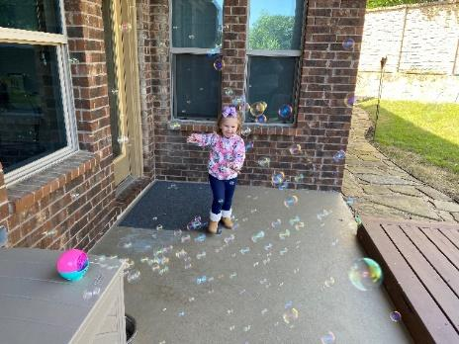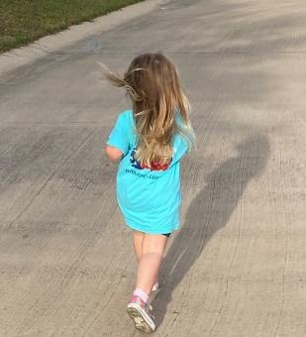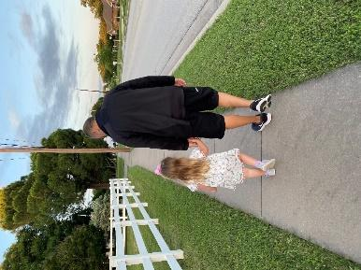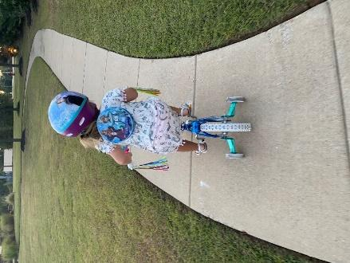
Preschoolers need movement, yet, they also need rest. Rest doesn’t necessarily mean a nap. It just means quiet time to calm down and slow the breathing. We even incorporated yoga into our days by using kid friendly videos I found online.
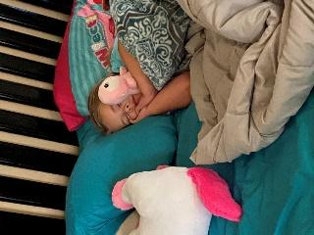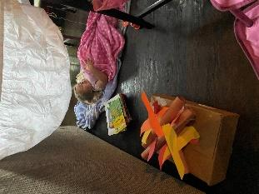
The times we live in can be stressful and challenging for the adults as well as for the children. Providing meaningful opportunities to slow down and connect with each other without any distractions is powerful.
Generate a list of ideas for movement and rest for parents to try at home, but also encourage them to be creative and do what feels comfortable for their family.
We must create a balance in our days; bringing a sense of order to the chaos. Healthy children need healthy adults; mind, body, and soul. So, just breathe.
Opportunities to Explore Nature
Exploring nature became a necessity for me as I was not used to being tied to my computer all day, so I needed brain breaks. Additionally I felt tremendous guilt for the amount of screen time my daughter was getting.
Our nature explorations were simple. We collected flowers, hunted for rocks, and gathered acorns and pinecones. We completed scavenger hunts searching for certain items or all the colors of the rainbow. A magnifying glass was a fun tool to take on our walks and later used to examine our treasures. My daughter is actually a great little treasure finder. I keep a bucket by our front door so we can dump our daily ‘treasures’. She created pictures by gluing items she found to paper. In our neighborhood, people paint and hide rocks, so we did this too. The idea is to rehide the rocks you find, however, I must apologize because my daughter cannot part with any we have found. Sigh.
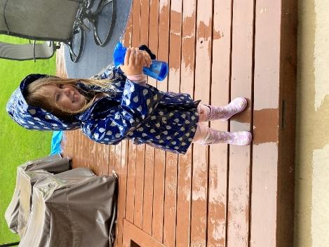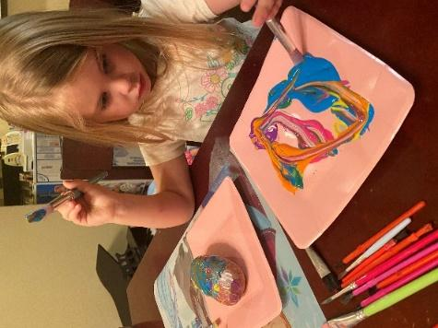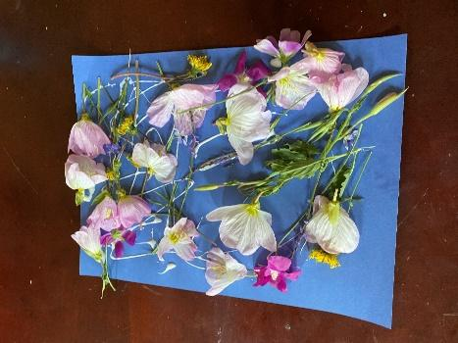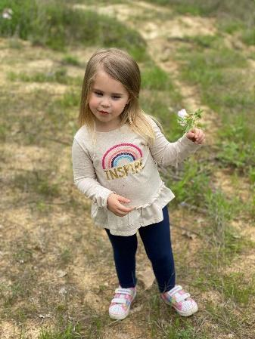
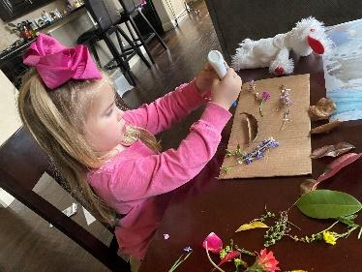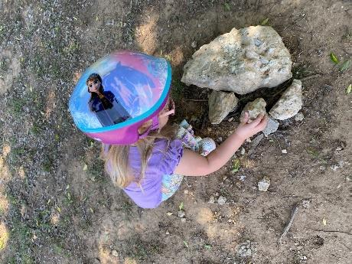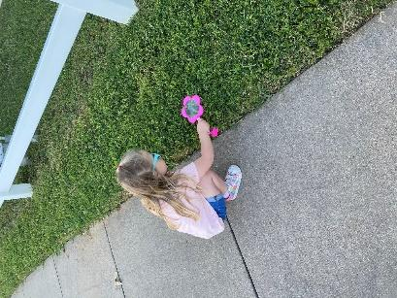
Dance in the rain. Draw with sidewalk chalk. Dig in the dirt. Just play outside.
The best gift you can give young children and their parents is to schedule time to log off the computer and encourage them to explore nature.
The preschool years are some of the most important years in a child’s life. Their brains are growing at rapid rates, and they are learning their place in the world. Our job as educators and parents is to provide these young learners with the best opportunities we can for them to be successful humans.
Recommended Readings
Clarke-Fields, Hunter. (2019). Raising Good Humans: A Mindful Guide to Breaking the Cycle of Reactive Parenting and Raising Kind, Confident Kids. New Harbinger Publications.

Mraz, Kristine, Porcellie, Allison, & Tyler, Cheryl. (2016). Purposeful Play: A Teacher’s Guide to Igniting Deep & Joyful Learning across the Day. Heinemann Educational Books.

Suskind, Dana. (2015). Thirty Million Words: Building a Child’s Brain. Dutton Hardcover.

Wood Ray, Katie & Glover, Matt. (2008). Already Ready: Nurturing Writers in Preschool and Kindergarten. Heinemann Educational Books.

