Dear Editor,

We wish to submit an article with the suggested title “Between Languages and Teachers: Bridging Worlds in One Classroom” for consideration by The Learning Professional.

We confirm that this work is original and has not been published, nor is it currently under consideration for publication elsewhere. We have no conflicts of interest to disclose.

In this article, we report the initial results of an exploration into biliteracy practices in early childhood as a way of providing more equitable learning through a more culturally and linguistically responsive pedagogical approach. Our professional learning community has also delved into ways pre-K and elementary grades can unite through commonly constructed values as we become more context responsive. We built our work on solid technical expertise in literacy and moved toward a deeper level of learning through an adaptive process that was and continues to be intentionally supported through specific principles of professional learning. We believe the three topics in this article: equity, early childhood practices, and uniting perspectives through adaptive change processes is specifically interesting to your readers because your April 2021: Early Learning issue lists “build equity in the early years” and “building bridges between pre-K and the elementary grades” to be of special focus areas.

This article has a word count of 2,301 words and has been created by the following three authors. Maria Patricia Mesa, (mpmesa@cng.edu) and Vanessa Gilchrist (vgilchrist@cng.edu) are Biliteracy Coaches at Colegio Nueva Granada, Bogotá Colombia. Barbara Noel, Ph.D. (barbaranoel@language4learning.org) is an affiliated professor at the University of Alabama and is founder and director at Language4Learning. She is also a co-author of two recently published articles:
- Gottlieb, M. & Noel, B. (2019). Character Development in a Multilingual International School and Its Use of Self-Assessment Tools. Sino-US English Teaching. Volume 16, Number 9, September 2019 (Serial Number 189)
- Gottlieb, M. & Noel, B. (2018). Language Learning within Inquiry. Language Magazine. Sept. Edition.

Please address all correspondence concerning this manuscript to Barbara Noel at barbaranoel@language4learning.org. Her contact information is: tel - 571-800-7279 and address: 3535 Cornell Rd. Fairfax, VA 22030.

Thank you for your consideration of this manuscript.

Sincerely,

Barbara, Maria Patricia, and Vanessa
Article Draft

Throughout our professional practice and consulting work, the common trend we have seen in early literacy practices with multilingual students is that the language of instruction and our students’ home languages are worlds apart in one classroom. This often leads to fractured learning at a time when our students most need to draw from their entire cultural and linguistic repertoires in order to understand what is happening in the classroom. We are committed to finding literacy practices that better serve our students and honor who they are.

Equity as the Driver for Our Collaborative Inquiry

At schools like ours, the emphasis is on developing academic English with a student population where over 90% of our students are native Spanish speakers. This typically means that our preschoolers, starting at age 4, begin formal schooling in a language that is entirely new to them. In response, our school has provided tremendous amounts of technical training for almost a decade and this has raised literacy levels within a rigorous workshop-style literacy program.

Yet on an adaptive level, teachers, coaches, and administrators have begun to question how our literacy program should move beyond just best practices and more towards culturally and linguistically responsive pedagogy. In this process, some of the questions that have arisen are: “Should we only use English for a program that is designed for English native speakers? Why are we doing it this way? Is there a better way? What is the role of Spanish in this process? What is the role of students’ cultural identity in the literacy process? As coaches and consultants, we also wondered: “How can we leverage our own bilingual assets to better support teachers in applying the curriculum?” In effect, our questions centered around equity. “How might we, as educators, value and build on the richness and strengths our students bring from their home languages and cultures to ensure more robust learning opportunities?”

As we dug deeper we noticed two more equity issues impacting our students’ early literacy development. First, we observed that there are gaps in expectations between our primary school (PS) staff and elementary school (ES) staff for the language and literacy levels our students should attain. For the first time, we shifted our attention from the units of study, to the implications of teaching multilingual learners within the structures of the workshop model. “Where might we be unintentionally erecting barriers to literacy development between school levels?” “What new insights might inform or help us shift our existing mindsets?” Second, we needed to develop more clarity about the role of the Spanish program for both native speakers and students for whom Spanish is a new language with regard to early literacy development. Historically, the English and Spanish departments taught the same units but still worked separately and isolated from each other. As a result, the practices around workshop teaching varied from teacher to teacher, from English to Spanish, and from PS section to ES section. These observations led us to ask, “How might we move the Spanish and English programs from being two separate worlds into one that is purposefully coordinated in a coherent manner?”

For these reasons, our senior leadership invited a group of educators from the ES/PS buildings, from English, Spanish, and Spanish as a new language (SNL) programs, to engage in meaningful conversations about literacy practices in both languages. It was perhaps the first time that such a diverse and powerful group of teachers was sitting together under the same roof. Together we focused on ways to build linguistic equity in the early years while also building bridges between pre-K and the early grades. It was a time of reflection, of acknowledging one another, and of bringing to the table assumptions that have historically divided us. Some of these encounters resulted in tears and honest remarks. We literally built bridges with fettuccine and marshmallows and, as we were reflecting upon the value of our bridge structures, we also started to realize that the work that we were doing was greater than just making sure that our models would not fall.

Bridge-Building through a Culture of Professional Learning

We began scrutinizing our own biases and the potential bridges we could make through our ‘languaging’ practices. Therefore, we formally established our Professional Learning Community (PLC) and we defined our work as follows:

Purpose: To build a thorough understanding of biliteracy and how it encourages diverse, equitable, and inclusive learning to develop students’ individual potential as global, intercultural, and bilingual citizens.

Vision:
- To inquire into research and best practice around biliteracy for early years.
- To construct a shared understanding of biliteracy.
- To pilot tools.
- To end with a proposal for an Early Literacy Philosophy, Essential Agreements, and Action Planning.

We gathered homeroom, Spanish, and SNL teachers, administrators, and biliteracy coaches for meetings every other week with the purpose of exploring strategies and concepts from professional readings. As we unraveled each chapter, and followed a variety of protocols aimed at opening opportunities for research, action, and reflection, it started to become evident that there are more practices that unite us than divide us between language programs and school sections. We also saw that there are many connections between the practices that the readings explored and the ones that pertain to the workshop model. The bridges that we built served as foundations for deep level work that goes beyond simply practicing strategies in a classroom. We also saw a need to be more aligned in our curriculum and coordinated in our literacy practices. New questions arose about the amount of time allotted to literacy in both languages, skill and capacity, and wonderings about the kind of school we are and how we view and value our multilingual students in a bilingual program. This led to the following actions that recognized and communicated the schools’ firm commitment to professional learning:

- Instructional coaches redefined their titles to ‘Biliteracy Coaches’
- Formed grade-level teams that fully integrated Spanish teachers into all aspects of coordination on both the PS and ES sections.
- Hired two new Spanish teachers to allow for greater integration
- Redesigned schedules to allow for common planning time between English homeroom and Spanish teachers.
- Hired an assistant national program director for the Spanish program.
- Began using the same Common Core State Standards for English and Spanish in PS and more standards alignment in ES.
- Began using the same assessment tools across languages to calibrate writing thereby ensuring all teachers work toward a common goal.
- Decided to continue our Early Literacy PLC into a second year.

Resources

Escamilla, K., Hopewell, S., Butvilofsky, S., Sparrow, W., Soltero-Gonzaléz, L., Ruiz-Figueroa, O., Escamilla, M. (2014). Biliteracy From the Start: Literacy Squared in Action. Philadelphia, PA: Caslon Publishing.

Lara, M. (2017). “¡Toma la Palabra!” Irving, TX: Seidlitz Education.

Effective Instructional Practices
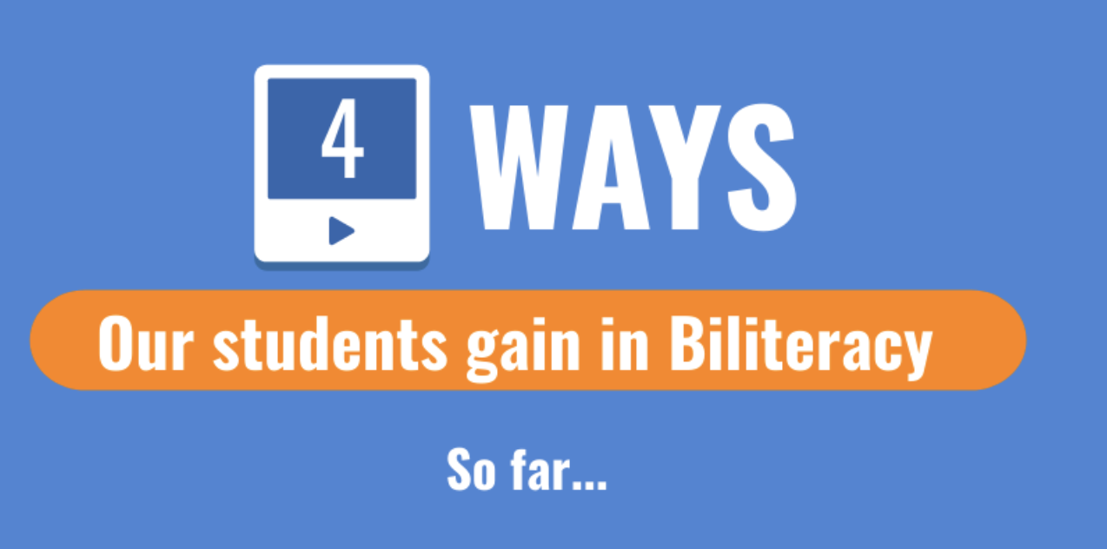
Four months later, these actions have already created positive impacts for students. Through our online Zoom sessions, we asked our thirty member group what they have been noticing and want to keep nurturing. Their responses can be grouped into the following categories:

- Coherence for student learning emerges when teachers share standards, assessments, practices and strategies across language programs and school sections. Learning is being guided with aligned standards for both the English and Spanish programs enabling teachers to see the whole child and not just the English or Spanish child in their program. Vertical teams are integrating teachers across both languages and both PS and ES sections. As a result, our students are understanding content better. They generate higher quality ideas through bilingual brainstorming. They are now making more emotional connections in their literacy experiences.
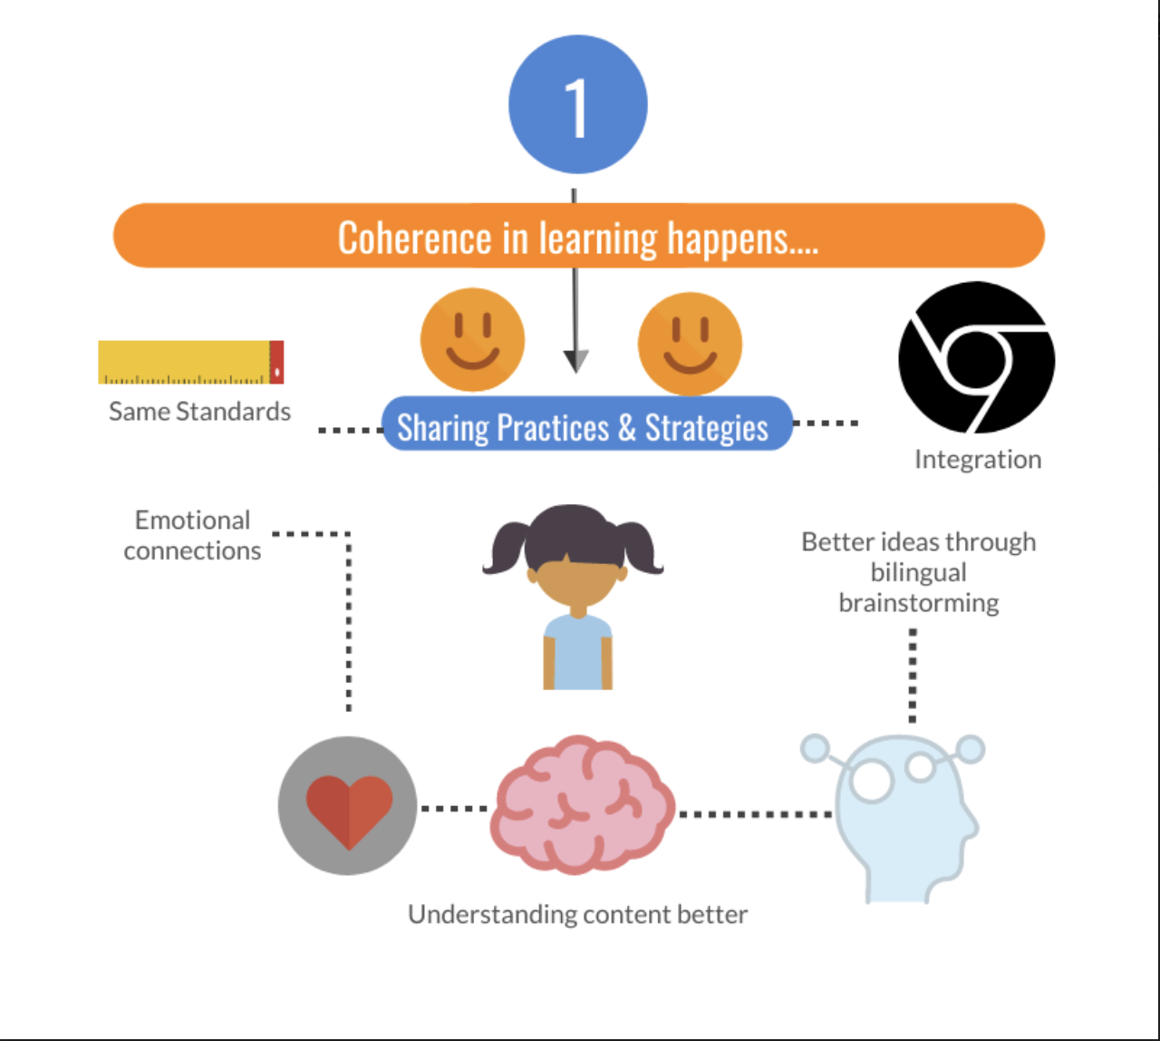
- Languages complement each other throughout the literacy program when teachers co-plan units and lessons across languages. Anchor charts comparing the language features of both languages and bilingual word walls are appearing more frequently. Coaching cycles with the same learning targets are being used across language programs. Teachers are beginning to see student skills and ways of thinking growing more evenly between both languages. They are also seeing higher levels of student engagement. Likewise, parents are beginning to see that their children are more motivated to write and share their learning.
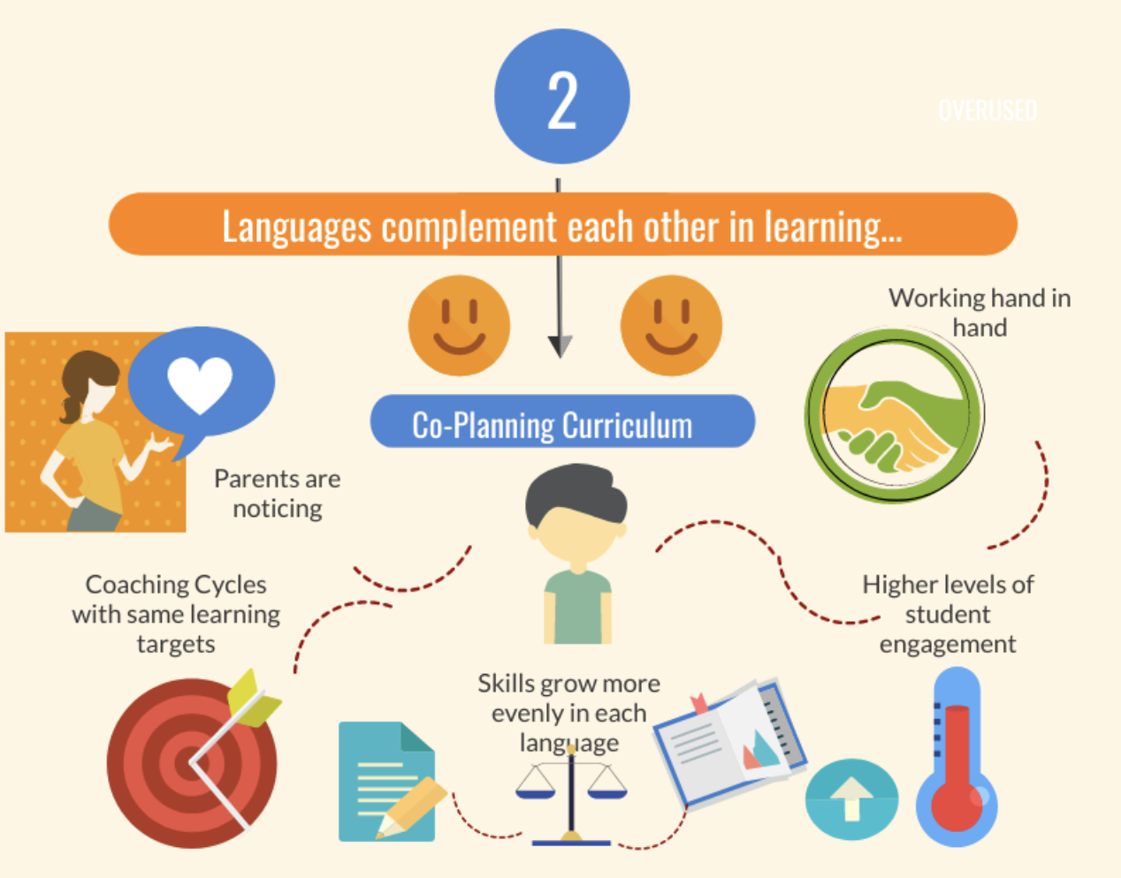
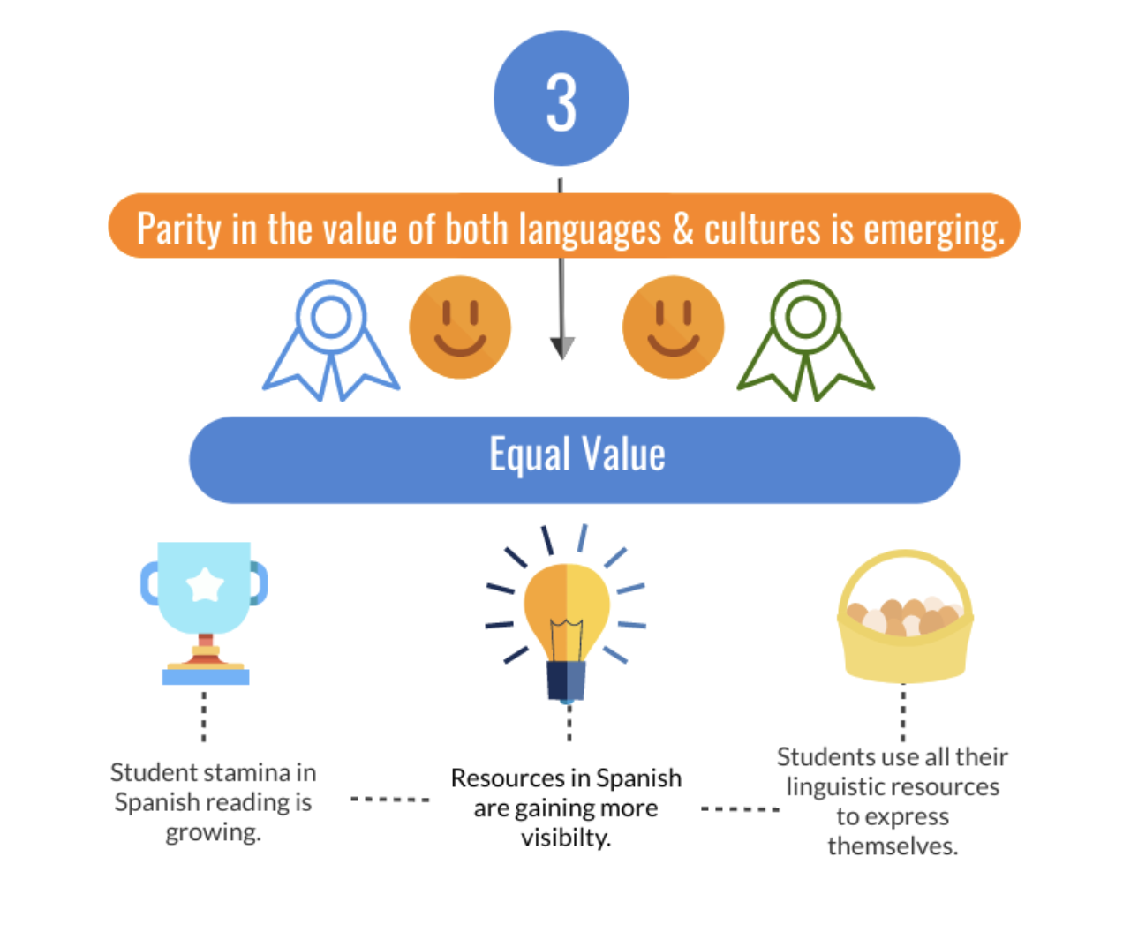
- Parity in the value of both languages and cultures honors student identities in learning. Students are seeing more Spanish resources showing up around the classroom. Thus, students are growing more stamina and interest in reading in Spanish. Students are beginning to use all of their linguistic resources to express themselves with more fluency and frequency.

- Equity in practice grows as teachers purposefully plan when and how to use both languages. Teachers are beginning to justify their choices for which language to use based on intentional pedagogical purposes. This, at times, looks like introducing new concepts in a student’s home language before transferring to the new language. At other times, the new language might be used and the home language is brought in at a later time to ensure balanced growth. Additionally, as the need arises, teachers may use a student’s home language to address emotional concerns. This leads to greater depth of understanding and clarity, especially with pre-K students.
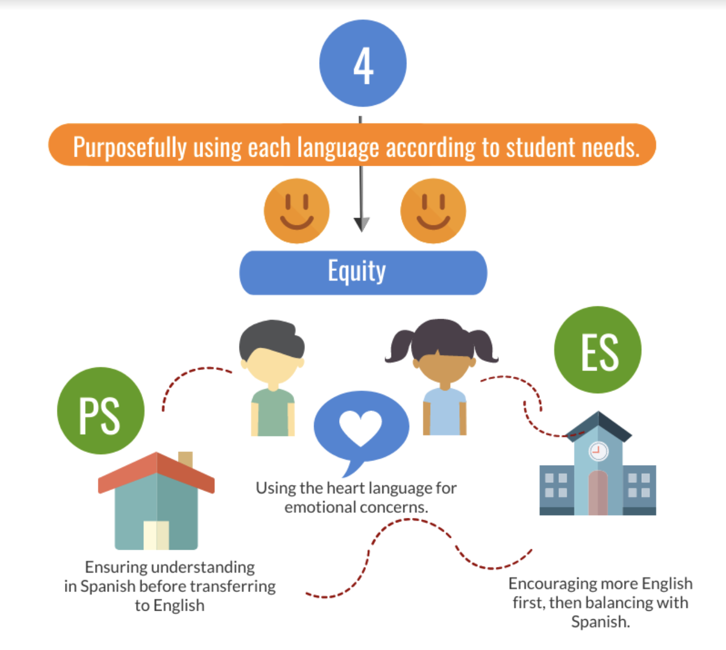

Support Matters
As the pandemic hit our world, the PLC was put on pause and we all joined efforts to navigate the circumstances and the new reality, in distance learning mode. This gave the PLC leaders a chance to reflect on the best ways to provide context and support leading to potentially more successful professional learning outcomes. Our framework for collaborative inquiry can be described around 6 lynchpins for adaptive change identified by Donohoo and Velasco, 2016. We have re-launched our PLC as we move into our second year centered on these principles.
- Voluntary participation. All biliteracy coaches, teachers, and administrators are invited and participation is based on commitment versus a sense of compliance to management.
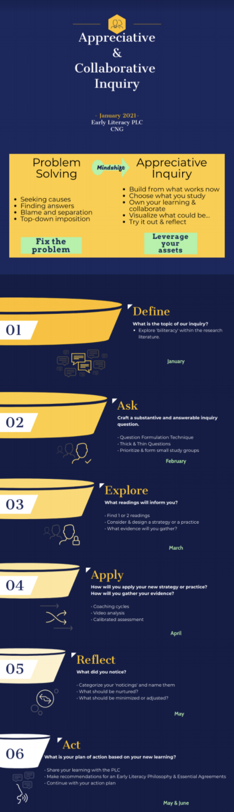
- Shared Leadership. This self-study was initiated by the Director and the Associate. Director for Learning & Teaching. The fact that they both initiated and supported this movement was pivotal for building the necessary trust to open up sincere conversations among teachers. Responsibility has now passed to the PS and ES principals and the national program director who oversees the Spanish Program. The biliteracy coaches have also been invited to lead because their role is critical in supporting sustainable change through an inquiry and data-informed stance. Additionally, an outside consultant has been guiding and monitoring this process over the past two years.
- Guided from Experience. We re-launched our PLC from an appreciative inquiry orientation in order to re-establish trust and build from the solid experience, skills, and talents of our group members. We began by exploring teachers’ observations, dreams, and discoveries of what is already working well. Therefore, we are starting our inquiries on an asset-based vs. a problem-solving stance. We will choose what we want to study and thus, own our learning. We will visualize better ways, try them out, and reflect on student learning impact.
- Achieved Coherence. While the school improvement process was initiated in a top-down manner by senior leadership, responsibility and ownership have now shifted to teachers through an organic, grass-roots process. We are now forming inquiry teams based on teacher questions about their own classroom practices. In this way, we are achieving a balance between institutional and teacher driven interests.
- Learning is Recognized and Disseminated. The results from the first year of the PLC were communicated to the entire school community. This led the teachers toward greater engagement with the purpose and vision of the PLC because the balance of top-down and bottom-up processes of change was honored. This ought to continue as the collaborative inquiry cycles reach shareable conclusions.
- Skilled Facilitation. We have followed a nested model of support to promote greater chances of success. At first, an outside consultant worked mostly with senior leadership. Ownership was passed to the PS and ES principals and the national program director. The consultant facilitates planning meetings, orients the leadership team, and monitors the participation of the larger PLC team. This allows the principals and director to focus on facilitating the meetings. The biliteracy coaches, in turn, work directly with the inquiry teams to apply new practices and push thinking as teachers critically analyze impacts on student learning. This depth of support promises to enable our professional learning to spread across the community and improve sustainable change processes.
“Successful and sustainable improvement can... never be done to or even for teachers. It can only ever be achieved by and with them.” (Hargreaves and Fullan, 2012, p.45)
Linguistic & Cultural Equity
Professional Learning
Technical Capacity  (Phase 1) | Adaptive Capacity  (Phase 2)
- Program Fidelity  - Shared Vision  - Clear answers  - Data-driven  - Sharing Strategies | - Context Responsive  - Shared Values  - Reflective Questions & Inquiry  - Data-informed  - Creating New Applications

A surface-level change can equate to technical fixes such as deciding which goals to offer students at varying literacy levels or whether to use power standards. Alternatively, deep-level changes require adaptive creativity driven by a shift in mindset. This might look like developing more oracy in two languages on a specific topic before launching into a new unit, or engaging in comparing language features across two languages. These new practices result from teacher reflection and a commitment to disrupt a ‘business as usual’ stance because they are convinced that there are better ways to respond equitably to students through professional collaboration and a “growth mindset” (Dweck, 2006). As we move forward, we biliteracy coaches, PS and ES teachers, and Spanish and English counterparts grow in mutual appreciation as we recognize the diverse strengths that each brings in service to our multilingual students in a bilingual program.

REFERENCES:
Donohoo, J. & Velasco, M. (2016). The transformative power of collaborative inquiry: Realizing change in schools and classrooms. Corwin Press.
Dweck, C. (2006). Mindset: The new psychology of success. Random House.
Hargreaves, A., & Fullan, M. (2012). Professional capital: Transforming teaching in every school. Teachers College Press.

