COVER PAGE

Learning Professional Editors-

Please accept this article that explores our journey in support of high-quality early learning.
We look forward to and welcome your feedback.

Warmly,
Betsy Fox, Irma Jean Gaona, and Larrisa Wilkinson

Theme and date of issue for which the manuscript is being submitted: April 2021: Early Learning
Suggested Title Of Article: Building A High-Quality School District Early Learning System Through Professional Learning
Writers’ Names:
- Betsy Fox, Early Learning Consultant
- Irma Jean Gaona, Coordinator of Early Childhood Programs and Curriculum Support, East Central Independent School District
- Larrisa Wilkinson, Director of Professional Development and Program Innovation, Pre-K 4 SA
Complete contact information for the writers
Betsy Fox, Early Learning Consultant
50 Heritage Drive, San Rafael, CA 94910
415-717-8934
betsy@foxeducationalconsulting.com

Irma Jean Gaona, Coordinator of Early Childhood Programs and Curriculum Support, East Central Independent School District
6634 New Sulphur Springs Road, San Antonio, TX 78263
210-724-0451
irma.gaona@ecisd.net

Larrisa Wilkinson, Director of Professional Development and Program Innovation, Pre-K 4 SA
633 S. St. Mary’s Street, San Antonio, TX 78205
571-271-1589
Larrisa.Wilkinson@sanantonio.gov

Word count:
Not including information in boxes: 2061
Including information in boxes: 2205

Photographs
Available upon request

BUILDING A HIGH-QUALITY SCHOOL DISTRICT EARLY LEARNING SYSTEM THROUGH PROFESSIONAL LEARNING
Betsy Fox, Irma Jean Gaona, Larrisa Wilkinson

Picture this scenario: a noisy room full of elementary principals building towers with playdough, straws, and toothpicks while laughing, talking, and sharing ideas (and competitively checking the progress of other table groups). During a year-long program with school and district leaders, we begin with this activity to engage principals in understanding how playing to learn supports both social and academic development of young children. As part of our overall early learning quality improvement process, we train elementary principals in early learning pedagogy in order for them to better support quality instruction in our programs serving four-to five-year olds. We strongly believe the impact and application of teacher training is much deeper with the knowledgeable support of school leaders. This is just one of the components of our district’s early childhood professional learning system which we will explore in this article.
While states and local communities are increasing access to preschool, there is a significant divide when it comes to the quality of early learning programs being offered to young children. Education and training requirements for preschool educators vary based on setting and state regulations. While professional learning opportunities may be offered, it is rare that effective job-embedded coaching and school-based leadership support is offered to support the implementation of new strategies.
Teaching our youngest learners is its own unique pedagogy. Developmentally appropriate and culturally relevant teaching and learning practices set the stage for ensuring that experiences are suited to each child’s developmental level. Children are arriving at preschool with a wide range of developmental abilities and a small but critical window in which to become kindergarten ready. Expectations for the field are substantially different than they were just a decade ago and we want to ensure we offer professional learning that is intentionally designed to build our teachers’ and leaders’ abilities to meet these demands. Early educators are being asked to provide rich educational experiences for all children with increasing demands for accountability. The ultimate goal of our district’s early childhood professional learning is that our educators understand and implement specific strategies that support each child’s development across cognitive, language, social-emotional, and physical domains.
We are proud of our district’s efforts to offer opportunities that allow our Pre-K educators to learn, share, question, and grow in order to offer the strongest Pre-K program possible. In addition, unique opportunities are provided to build the knowledge required for school and district leaders to support continuous improvement. The most recent draft of the Learning Forward Standards for Professional Learning validates the journey we are on while helping us consider our future steps.

OUR DISTRICT
In 2019, San Antonio’s East Central ISD hired a Coordinator of Early Childhood Programs, who began envisioning how to best meet the needs of our young children, their families, and the teaching staff. Irma Jean Gaona quickly realized the value of partnering with Pre-K 4 SA, a local tax-funded workforce development initiative whose mission is to “improve San Antonio’s workforce in one generation by changing the educational trajectory of four-year-olds across the city.” In addition to directly serving 2,000 children, Pre-K 4 SA provides over 10,000 hours of high-quality professional learning to 2,000 early educators across the city annually.

As a partner district, ECISD receives grant-funded support for curriculum implementation and educator training through the Pre-K 4 SA Professional Learning Department. As Larrisa Wilkinson, Pre-K 4 SA Director of Professional Development and Program Innovation states, “Pre-K 4 SA strives to provide a best-in class professional learning program that offers continuing education to early childhood educators throughout the city to impact the success of our early learners.” The following describes our district’s continuous quality improvement journey through this unique partnership.

OUR JOURNEY
CURRICULUM: Knowing that Pre-K 4 SA would support training and implementation for a curriculum that promotes active learning through play, we decided to implement HighScope, through which children are guided to explore and interact through purposeful play. It was a radical shift from a more traditional curriculum. Using High Scope, teachers increasingly focus on the foundations of developmentally appropriate practices. The program requires extensive professional learning which was a factor we had to seriously consider, “Could we commit the time for each teacher to participate in on-going intensive training? Did we have the allocated funds and enough substitutes for this level of training? Will leaders support a play-based curriculum?”

TEACHER TRAINING: We made the decision to adopt HighScope and commit to the training requirements, which allows content to be contextualized for our ECISD educators while ensuring quality program implementation. This in-depth training creates lasting change in teachers’ knowledge, skills, and dispositions; it doesn’t focus on merely implementing a curriculum. Because our teachers often have varying educational experiences, this provides all Pre-K teachers a common understanding of developmentally appropriate practices, ensuring an equitable and consistent Pre-K experience for all children. In addition, Pre-K 4 SA coaches provide job-embedded support for lead teachers and teaching assistants.

TEACHER ASSISTANT TRAINING: Our Pre-K teacher assistants are critical in the quality of our classrooms. Many of them come from our immediate community, are women of color, and are paid at a much lower rate than teachers. In an effort to support career advancement and a higher level of professional status while ensuring strong collaboration in each classroom, all assistants now have the opportunity to earn their Child Development Associate (CDA) credential, providing them with a foundation on such topics as: child development and learning, observing and assessing, family engagement, and meaningful curriculum. As Deanna Sears shares, “This opportunity came at the perfect time in my career as I was just starting to work towards my teaching degree. The content I learned about early child pedagogy in my CDA classes transferred to my college courses, helping me excel as a non-traditional college student.” As a district, we are excited that after this school year, 89% of ECISD Pre-K teaching assistants will have their CDA Credential in support of our goal of offering equitable access to high-quality professional learning.

ELEMENTARY LEADERSHIP TRAINING:
We know that school leaders are the second most important in-school factor impacting student achievement. Early childhood education is not typically covered in principal preparation programs, yet principals increasingly oversee programs for our youngest students. Over the past several years, organizations such as NAESP, New America, and ASCD have identified the need for elementary leaders to understand developmentally appropriate and equitable practices in early learning pedagogy. Knowing this as well as the fact that many of our principals have only taught older students, we partnered with Pre-K 4 SA through unique opportunities designed to build foundational knowledge in our elementary school and district leaders, helping to support Pre-K to K alignment.

Early Learning Institute for Elementary Leaders (ELIEL):
In the first two years, principals, assistant principals, and campus-based academic facilitators were trained on child, brain, and social-emotional development through a three-session, nine-hour series. In the third year, principals attend a series of seminars designed to deepen their knowledge of pedagogical topics including: child and brain development, classroom environment, playing to learn, social-emotional development, executive function, literacy, math, and family engagement. Equity topics are explicitly addressed but also form a continuous thread throughout the series. While content is based on research, there remains a focus on the practical, everyday life of an early childhood classroom with sessions created with a focus on adult learning theory based on constructivism. Principal Stacey Johnston states, “My experience with ELIEL this year has been eye opening. I have a background with older students, and it has helped me understand the workings of 4-year-olds and how they learn through play. The program has helped both my teachers and me with classroom layouts, learning styles, and child growth and development.” This program provides the ideal collaborative opportunity for principals and teachers to learn and grow together. Each principal also participates in “Walk & Talks” with the ELIEL consultant during which they apply session content to their schools’ classrooms. As these Walks are designed specifically to deepen principal learning, we ensure they don't function as a program/teacher assessment. As we walk through classrooms, we often start with the opening question, “What do you notice?” then use probing questions to encourage reflection and application of the knowledge from the seminars. A common refrain from principals is that these walks help them “see things differently.” In a visit just a few weeks ago, a principal realized the importance of having various cultures represented through materials, books, and visuals so that each child in the class receives a clear message of belonging. Principals often state these walks are excellent opportunities to apply their learning in a real-life context.

TAILORED PROFESSIONAL LEARNING COMMUNITIES (PLC) While PLC’s are designed to foster inquiry-based professional learning, our Pre-K teachers did not feel the meetings were addressing their specific needs. In reality, Pre-K PLC’s were, at times, a source of frustration for all involved. The Academic Facilitators (AF) who facilitated PLC’s often didn’t possess the content knowledge to adequately guide teacher collaboration and were needing support. In response to this situation, we trained a Pre-K teacher and AF from each campus as PLC co-facilitators. “The training was very thorough; I especially liked the immediate practice and feedback and have a better understanding of the PLC process itself,” mentions Angelina Gonzales, an AF. We intentionally designed these PLC’s to align Texas Pre-K Guidelines, data from our Pre-K assessment system (Teaching Strategies GOLD) and the HighScope curriculum, making the meetings relevant and practical. Each Pre-K teacher and AF team collaborates weekly to facilitate a tailored Pre-K PLC using inquiry cycles focused on authentic assessment data to inform teachers’ everyday teaching and learning. Teachers feel PLC meetings actually meet their professional needs and by having the AF’s actively involved, a true collaboration has been created that reaches far beyond PLC meetings. Megan Sandoval, a Pre-K teacher, acknowledges, “In participating in Early Childhood PLC’s, we are now a team that is committed to inquiry-based collaboration focusing on the growth of every child and every member of our ever-developing learning community.”

WHAT WE ARE EXCITED ABOUT
We are excited to have an aligned system of professional learning and support for Pre-K teachers and for school and district leaders. While teachers are learning and implementing the HighScope curriculum, AF’s are increasing their knowledge and support of Pre-K. Concurrently, principals and assistant principals are deepening their knowledge of developmentally appropriate practices, ensuring that teaching, learning, and expectations of young children are reasonable and equitable.

WHAT WE HAVE LEARNED
Implementing a complete system of aligned early childhood professional learning ensures that teachers receive the same messages from everyone. Whether a teacher learns something from a college course she is taking, from a principal or AF, from the teacher across the hall, a Pre-K 4 SA coach, or from a HighScope trainer, the message is similar.

Communication is key, both sharing information regarding changes as well as the “why” behind them. As we travel on our journey, we continually identify others who may need additional knowledge and information in order to best support our mission. We continue to consider how to train leaders on topics such as our child assessment system and the tailored Pre-K PLC approach.

NEXT STEPS
While the investment of staff time has been considerable, we realize that with just three years of effective professional learning, we have connected the dots and created a system in which high quality early learning can flourish. Now that our foundation of developmentally appropriate practice is strong, we look forward to deepening our discourse and participating in inquiry and professional learning to ensure that each child has his/her needs met. In the next year, we plan to develop a district early learning mission and philosophy statement, ensuring that all future decisions are aligned. We’ve discussed whether we might have begun with this step but at this point in time, recognize that we will have the educated involvement of teachers and leaders who possess the knowledge to contribute. We can use what we have learned the past few years to dictate where we head in the future. As we consider our vision to create a high-quality early learning program, we continue to ensure that all parts of the system are impacted through intentionally planned professional learning.

East Central ISD
Medium-sized district in San Antonio

7 elementary schools, 10,000 students
75% Hispanic; 9% Black; 15% White; 1.5% 2 races or more
68% economically disadvantaged
56% At-Risk

24 Pre-K classrooms
24 teachers; 27 teacher assistants

Building Early Childhood Leadership Across all Levels

2018-2019
- All elementary principals, Director of Curriculum & Instruction and Coordinator of Curriculum complete 9-hour early learning pedagogy series
2019-2020
- New principals, 5 academic facilitators, two assistant principals, and Coordinator of Early Childhood Programs complete 9-hour series
- Coordinator of Early Childhood Programs completes Early Learning Leadership Program
2020-2021
- 5 academic facilitators and 2 assistant principals complete 9-hour series
- Elementary principals and the Coordinator of Early Childhood Programs participate in the Early Learning Institute for Elementary Leaders (6 half days; school visits)
- Academic facilitators, 7 Pre-K teacher leaders, and Coordinator of Early Childhood Programs complete training to facilitate Pre-K PLC’s

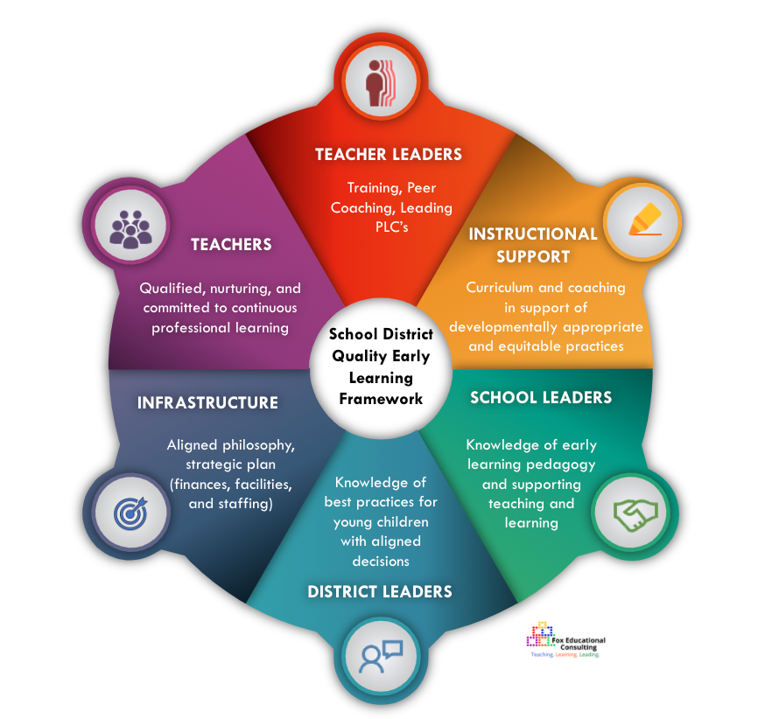
REFERENCES

Sheridan, S. Pope Edwards, C., Marvin, C., & Knoche, L. (2009). Professional Development in Early Childhood Programs: Process Issues and Research Needs, Early Education and Development, 20:3, 377-401. https://www.tandfonline.com/doi/full/10.1080/10409280802582795

Martinez-Beck, I., & Zaslow, M. (2006). Critical Issues in Early Childhood Professional Development. Paul H Brookes Publishing. https://books.google.com/books/about/Critical_Issues_in_Early_Childhood_Profe.html?id=I4-cAAAAMAAJ

Marzano, R., Waters, T., and McNulty, B. (2005). School Leadership That Works: From Research to Results. ASCD. http://www.ascd.org/Publications/Books/Overview/School-Leadership-That-Works.aspx

Sakai, L., Copeman, A., & Austin, L. (2017). Early Childhood Preparation for School Leaders: Lessons from New Jersey Principal Certification Programs. Center for the Study of Child Care Employment, University of California, Berkeley.

Lieberman, A., (2017). A Tale of Two Pre-K Leaders: How State Policies for Center Directors and Principals Leading Pre-K Programs Differ, and Why They Shouldn’t. New America.
https://www.newamerica.org/education-policy/policy-papers/tale-two-pre-k-leaders/

Franchino, E. (2019, December 16). The Bipartisan "Creating Early Childhood Leaders Act.” New America. https://www.newamerica.org/education-policy/edcentral/bipartisan-creating-early-childhood-leaders-act/

Learning Forward. (2020). Draft Standards for Professional Learning.

