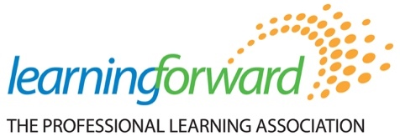

Building Capacity and Growing Influence
Affiliate Leaders Meeting
July 15-16, 2022
Hyatt Regency Minneapolis
Minneapolis, Minnesota

Agenda

Meeting Purpose:
To support affiliates as they continue to advance the Learning Forward mission, vision, and strategic priorities by providing resources and opportunities to engage with colleagues.

Meeting Outcomes:
Affiliate Leaders will…
- Engage in active learning with colleagues about Standards for Professional Learning
- Discuss ways in which affiliates can participate in current and future Learning Forward initiatives that support the strategic plan.
- Gather ideas from Learning Forward affiliate colleagues for strengthening your affiliate and contributing to your Learning Forward affiliate plans.

Day One: Friday, July 15, 2022
Room Name: Regency (2nd level meeting rooms)

1:00-1:15 Welcome
Elizabeth Foster

1:15-1:45 State of the Association
Frederick Brown, President/CEO

1:45-2:00 Advocacy Update
Jon Bernstein, Bernstein Strategy Group

2:00-2:45 Standards: Overview, Resources and Affiliate Strategies
Standards team (Paul Fleming, Elizabeth Foster, Machel Mills-Miles)

2:45-4:15 Equity and the Standards
Amy Colton, Learning Forward Foundation

4:15-4:30 Wrap up and next steps

Day Two: Saturday, July 16, 2022
Room Name: Regency (2nd level meeting rooms)

8:00-8:30 Breakfast

8:45-9:00 Welcome
Elizabeth Foster

9:00-9:30 Overnight Reflections
Affiliates share out

9:30-10:00 Affiliate Updates
Open discussion

10:00-11:00 Standards Implementation Tools and Resources
Machel Mills-Miles

11:00-12:00 Table discussions about Standards and implementation supports
Table discussions with padlet

12:00-1:00 Lunch with the Learning Forward Academy

1:00-1:30 Standards in Policy
Paul Fleming

1:30-2:15 What is next for your Affiliate?

2:15-2:30 Break

2:30-3:15 Closing discussions

3:15-4:30 RECEPTION
Affiliates, Foundation, Academy, Staff, Board of Trustees

