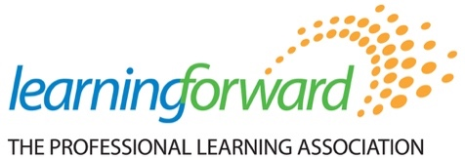

Building Capacity and Growing Influence
Affiliate Leaders Meeting
July 15-16, 2022
Minneapolis, Minnesota

Agenda

Meeting Purpose:
To support affiliates as they continue to advance the Learning Forward mission, vision, and strategic priorities by providing resources and opportunities to engage with colleagues.

Meeting Outcomes:
Affiliate Leaders will…
- Engage in active learning with colleagues about Standards for Professional Learning
- Discuss ways in which affiliates can participate in current and future Learning Forward initiatives that support the strategic plan.
- Gather ideas from Learning Forward affiliate colleagues for strengthening your affiliate and contributing to your Learning Forward affiliate plans.

Day One
Friday, July 14, 2022

1:00-1:15 Welcome and Overview of the Meeting
Elizabeth Foster

1:15-1:45 State of the Association
Frederick Brown, President/CEO

1:45-2:15 Standards: Overview of Affiliate Resources and Strategies
Standards team (Paul Fleming, Elizabeth Foster, Machel Mills-Miles)
Q&A

Table Discussions – Reflections on Resources
1, Feedback on what was shared
2, Priorities for what should be developed next

2:15-2:30 Share out
Capture ideas and consensus on priorities for resource development

2:30-4:00 Equity in Action
Amy Colton

4:00-4:15 Wrap up and next steps

Day Two
Saturday, July 20, 2019
8:30 AM – 3:15 PM

8:00-8:30 Breakfast

8:45-9:00 Welcome
Elizabeth Foster

9:00-9:30 Overnight Reflections
Affiliates share out

9:30-10:00 Affiliate Updates
Open discussion

10:00-11:00 Standards Implementation Tools and Resources
Machel Mills-Miles

11:00-12:00 Table discussions about Standards and implementation supports
Mix up tables

12:00-1:00 Lunch will be with the Academy and Foundation

1:00-1:30 Standards in Policy
Paul Fleming

1:30-2:30 What is next for your Affiliate?

2:30-3:15 Closing discussion

3:15-4:30 RECEPTION with Affiliates, Foundation, Academy, Staff, Board of Trustees

