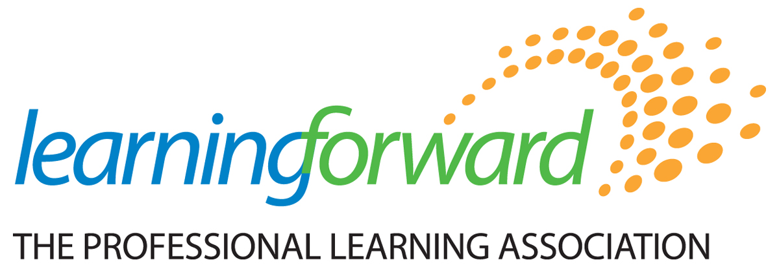
Building Capacity and Growing Influence
Learning Forward Affiliate Leaders Meeting
July 15-16, 2022 – Minneapolis, MN

Join your fellow affiliate leaders for two days of learning designed to increase your capacity to lead and influence professional learning in your state or province, provide resources and strategies to share with your board and members, and build your professional network.

Registration Form

Complete the following for each person attending in your delegation. Duplicate form as needed.

_______________________________________ _______________________________________________
Name (for your nametag) Affiliate and Position

________________________________________________________________________________________
Mailing Address

________________________________________________________________________________________
City, State/Province and Zip

______________________________ ________________________________________________________
Phone Email Address (your confirmation will be emailed to you)

REGISTRATION FEES

Day 1 - July 15 – 1:00pm to 4:30pm
Day 2 - July 16 – 9:00am to 3:00pm

☐ Registration per person…………………..………………………………..…...$199.00 ____________

SPECIAL REQUESTS

☐ Special diet required _____________________________________________________________________________________

☐ Special access requirements ______________________________________________________________________________

PAYMENT INFORMATION

☐ Check payable to Learning Forward (must accompany registration form)
☐ Purchase Order (must accompany registration form)
☐ Visa/Mastercard/Discover

Credit Card #: _________________-_________________-_________________-_________________ Exp. Date: _______/_______ V-Code: ________

Billing Address: _________________________________________________________________________________

Billing City, State/Province & Zip: ________________________________________________________________

Return registration form and fees by June 20, 2022, to:
For information about the meeting, please contact
Niki Gamble at 800-727-7288 or niki@learningforward.org.
Learning Forward • 504 S. Locust Street • Oxford, OH 45056
800-727-7288 • Fax: 513-523-0638 • Email: niki@learningforward.org

Building Capacity and Growing Influence
Learning Forward Affiliate Leaders Meeting
July 15-16, 2022 – Minneapolis, MN

Affiliate leaders will engage in discussions about Standards for Professional Learning, aligned resources and implications for how affiliates can raise awareness about Standards and support implementation and policy adoption in your own state, province or region.

This will be a great chance to learn alongside colleagues from other affiliates through panels, discussions and workshops. We will focus on affiliate operations, nuts and bolts of membership and events, equity and advocacy.

Meeting Information
DAY 1 – Friday, July 15th
1:00p.m. to 4:30p.m.
This day will include:
- An overview of Standards revisions
- A panel of affiliates discussing their current equity contexts
- Website/technology workshop

DAY 2 – Saturday, July 16th
9:00a.m. to 3:00p.m.
This day will include:
- Standards deep dive with Learning Forward’s Standards team
- Review of action guides including IC Maps
- Networking lunch
- Standards policy and implementation discussions
- Discussion of new online Affiliate course

Travel Information
HOTEL
Hyatt Regency Minneapolis
1300 Nicolet Mall, Minneapolis, MN 55043
For Guest Room Reservations: https://www.hyatt.com/en-US/group-booking/MSPRM/G-LF22
Guest room rates start at $169 + tax per night. The Learning Forward group rate is available between July 10-21.

AIRPORT
Minneapolis-St. Paul Int’l Airport
Travel Distance: Approximately 10 miles
Travel Time: Approximately 20 minutes

Return registration form and fees by June 20, 2022, to:
For information about the meeting, please contact
Niki Gamble at 800-727-7288 or niki@learningforward.org.
Learning Forward • 504 S. Locust Street • Oxford, OH 45056
800-727-7288 • Fax: 513-523-0638 • Email: niki@learningforward.org

