Data storytelling for advocacy toolkit

Use this toolkit to help plan for, prepare, and share your data-based stories for advocacy.

Preplanning the story

Audience
Who is the audience?
Why would the audience care?
Data preplanning: What data would appeal to the audience?

Examples: policymakers, community members, general public, budget gatekeepers

Purpose
Why are you telling the story?
What feelings do you want the audience to adopt?
What can the audience learn from the story?
What action do you want the audience to take?

Example:

Data
What benchmark data shows the “before” and “after”?
What data would best show you have achieved your vision?
Do you already have the data or will you have to collect it?
Who will manage the data gathering and preparing?

Story structure for advocacy

A situation
Where are we now? / Where were we in the beginning?
What benchmark data shows the “before” and “after”?

Challenge
What is the vision for after the change?
Tool to help develop your vision for outcomes
What data supports the need for change?

Solution
What were the options for how we could respond?
Why was the chosen response selected out of all the possibilities?
What data supported the response selection?

Impact
Successful or unsuccessful?
How does your “after” data compare to the “before” data?
Lessons learned?
What it means going forward / What is the significance?
What details show the learning/change that happened?

Make it easy to digest
- Make it skimmable. Most people will only skim for a fraction of a second before they decide whether or not they will read deeper.
  - Divide the content into small, chunks that are easy to understand.
  - Use visual clues and hierarchy to guide the reader’s eye
    - Larger text and images are viewed first
    - Darker items are viewed before lighter items, so lighter text is viewed after darker text.
    - Be aware of placement – some items traditionally appear in certain places, so people are accustomed to viewing them in a certain order:


- Graphics and images should only be used if they help make the story or the data easier to process. Tip: If graphics require explanation beyond simple labels, they are not making it easier.
- Charts are not all created equal, be sure the chart is right for your data and purpose.
  - How to choose the best charts
- Focus on one strong and clear message. Multiple messages dilute the power of your strongest message.
- Use just one call to action. Asking your audience to do one thing keeps them focused and gives them a clear and strong path forward. Adding multiple actions interrupts their flow from your ask to action. It can create confusion as to what they should do next, causing many people to simply disengage.
- Keep it concise. Everything should support the primary message. Our brains work on a subconscious to avoid wasting energy, including while reading or listening. If you include content that is not essential and relevant, people will tire and feel like your story is a waste of time without even realizing why they are putting down your story or no longer listening.

Helpful resources from Learning Forward
Tools
- Data summaries are one- or two-page summaries of your data story. Learn more about them, download a tool from Learning Forward to help build data summaries, and see examples of data summaries from other districts: https://learningforward.org/title-iia-data-summaries/
- “Laser talk: Use the EPIC acronym” and “Laser talk: Make your delivery” https://learningforward.org/lf-newsletter/tools-laser-talk-use-the-epic-acronym-and-laser-talk-make-your-delivery/
- Tools for Schools issue devoted to how to influence policy and how to frame a persuasive story: https://learningforward.org/wp-content/uploads/2008/02/february-2008-tool.pdf
- Slides from a conference session on Sharing your professional learning story: https://learningforward.org/wp-content/uploads/2022/02/storytelling-session-toronto-PDF.pdf

Webinars
Watch these webinars to see how other educators have gathered data to demonstrate impact of their professional learning systems
- Collecting evidence to share impact of professional learning: Districts share their stories https://learningforward.org/webinar/collecting-evidence-to-share-impact-of-professional-learning-three-districts-share-their-story/
Click here to skip the first 12 minutes of previous federal policy updates and go straight to the practitioners sharing their stories.

- Documenting your Professional Learning Story: Showing the Impact of Professional Learning
https://learningforward.org/webinar/documenting-your-professional-learning-story-showing-the-impact-of-professional-learning/
Click here to skip the federal updates and go straight to the practitioners sharing their stories.

Resource database
- Search our resource database for articles, tools, blog posts, and webinars to help you in your work: https://learningforward.org/search-resources/ Search by keywords, type of content, publication, date, or one of our curated professional learning topics.

How to deliver the story
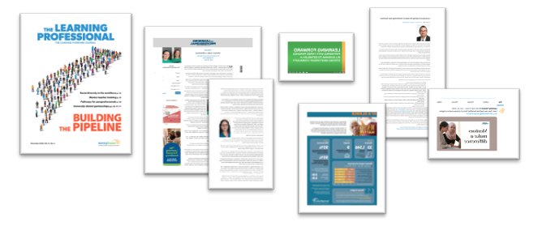

- What medium will work best for the audience and purpose?
  - Print
  - Digital
  - Video
  - Verbal
- Adaptive distribution strategy
  - Start with the full story or report
  - Pull excerpts, summaries, and quotes that adapt to other mediums, spaces, lengths, and purposes.
    - Full articles
    - Conference sessions
    - Webinars
    - Letters to the editor
    - Blog posts
    - Infographics
    - Videos
    - Social media graphics and posts

Reminder!
Don’t forget to share your stories with others in the field using Learning Forward’s Powered by Title II website: https://poweredbytitleii.com/share-your-story/

We will share your stories with others as examples of the power of professional learning.

Additional reading/viewing

TED talk: Brain science and storytelling
https://www.ted.com/talks/karen_eber_how_your_brain_responds_to_stories_and_why_they_re_crucial_for_leaders?language=en#t-209832

TED talk: The counterintuitive way to be more persuasive
https://www.ted.com/talks/niro_sivanathan_the_counterintuitive_way_to_be_more_persuasive

Article: Back to the story spine
https://www.aerogrammestudio.com/2013/06/05/back-to-the-story-spine/

