Zoom recording management

Table of Contents
How to download your recordings to your device 2
How to delete your recordings 5
How to recover your deleted recordings 7
How to move your recordings to Dropbox 10
How to share recordings on Dropbox 12

How to download your recordings to your device

- Sign into your Learning Forward Zoom account at https://zoom.us/signin.
- If you have a webinar account, skip to step #5. If you have a regular account without webinars, continue to step #3.
- Click on Recordings on the far left of the screen.
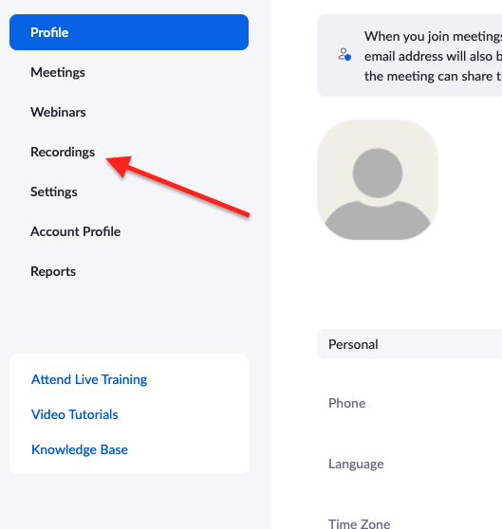
- On the next screen you can share, download, and delete your recordings. Skip to step #8 for details on how to do these.
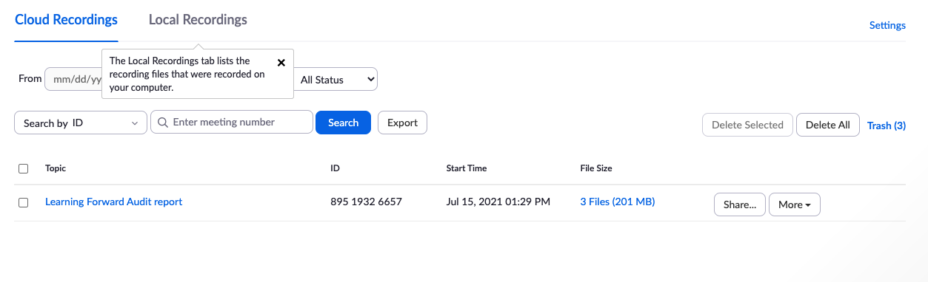
- If you have a webinar account, find and click on ‘Account management’ under the ‘Admin’ section to the left of the screen
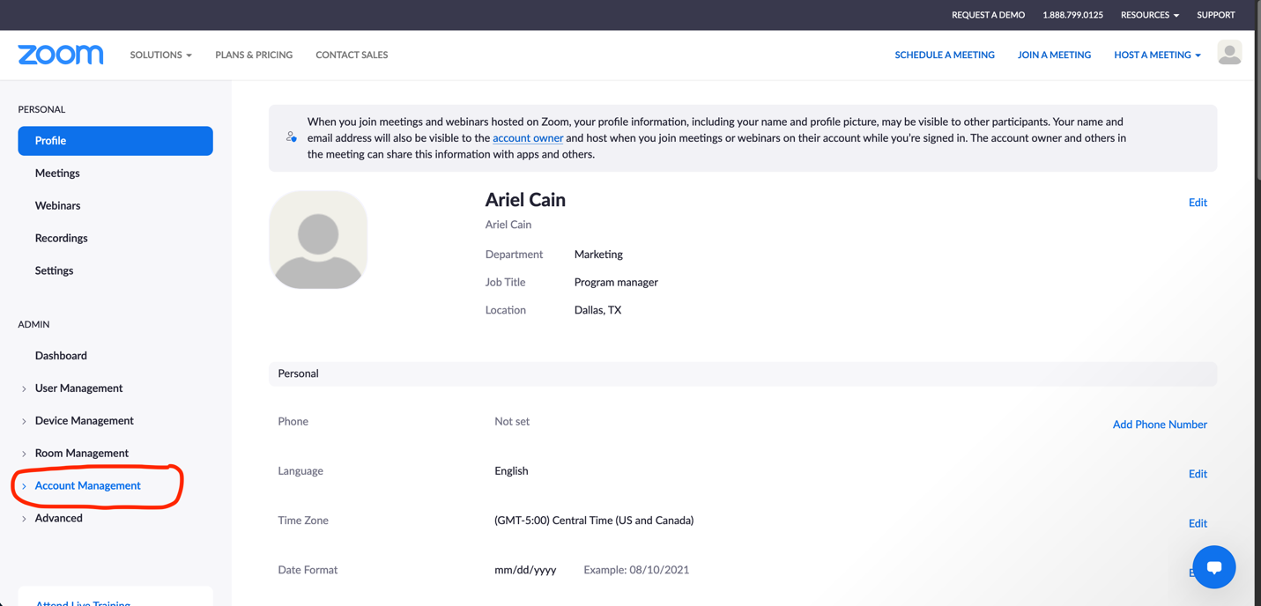

- Click ‘Recording management’
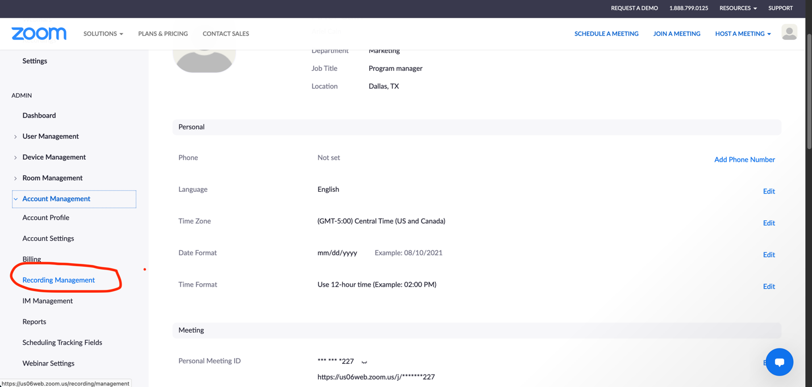

- On that screen, you will see the full list of recordings from all staff accounts. You can pull up a list of only your recordings by typing your Learning Forward email address in the search box. (Make sure the ‘search by host’ filter is on)
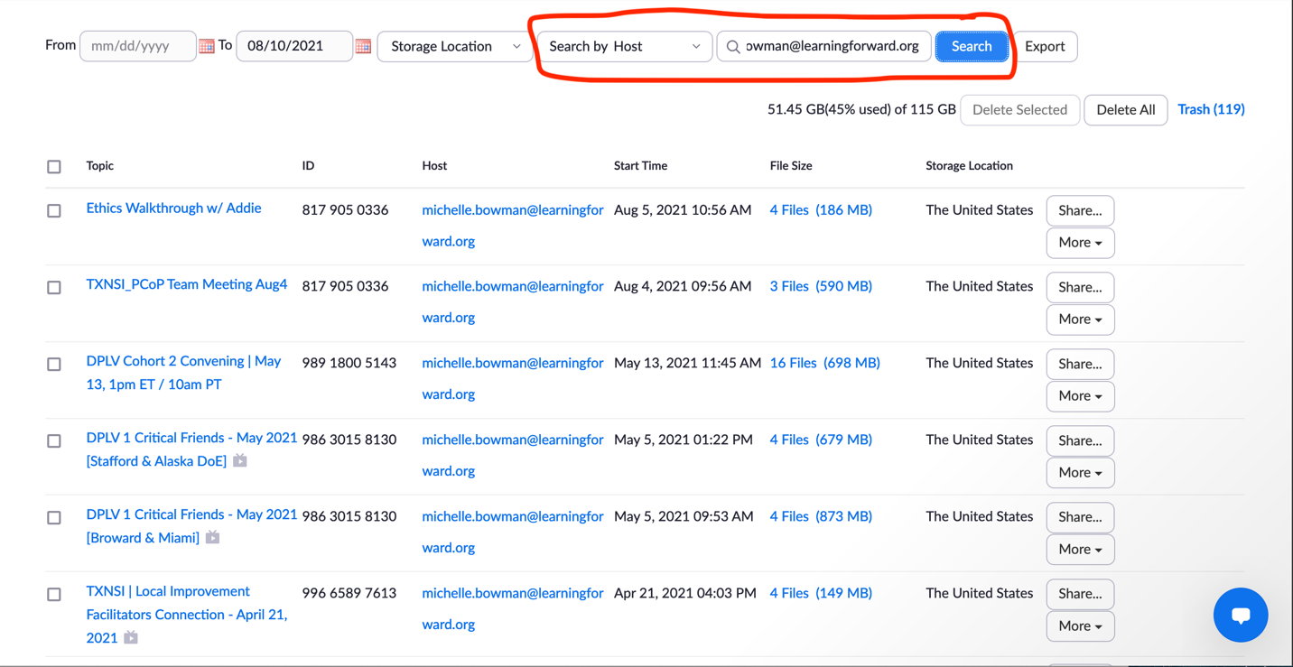

- Click on the recording you would like to download
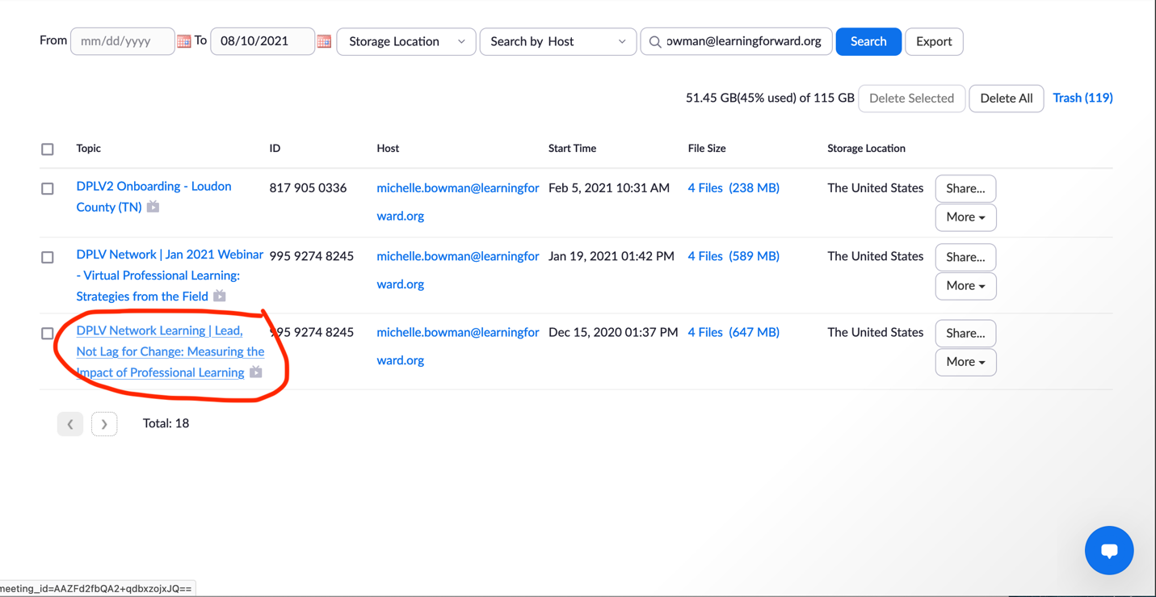

- You will then see the available files for the recording. Usually there are four files: A) MP4 version of the recording; B) audio-only file of the recording; C) audio transcript; and D) chat box file. Hover over the file you would like to download and click the down-arrow icon to download that specific file.
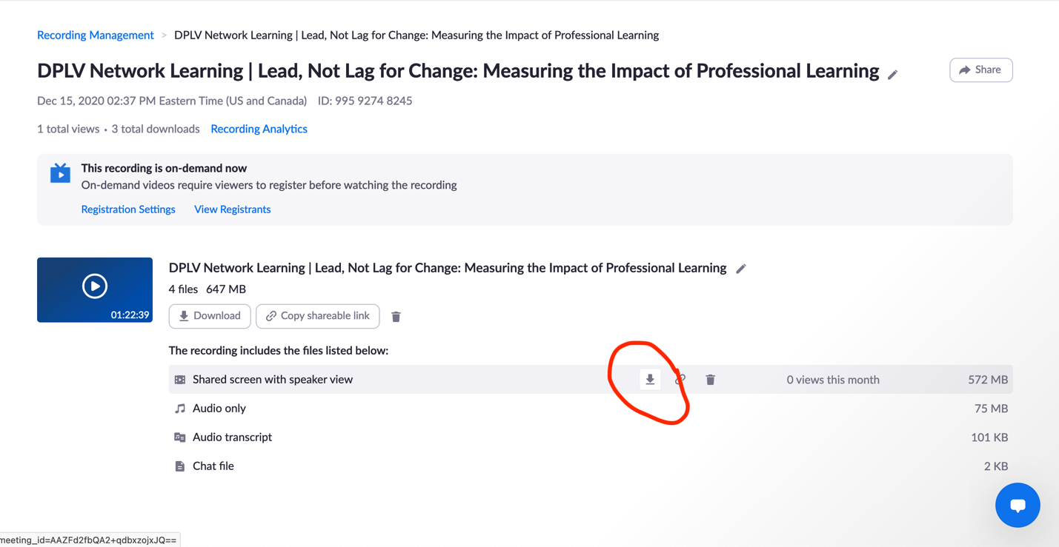

- When the pop-up screen appears, click the save button to save the file to your device.
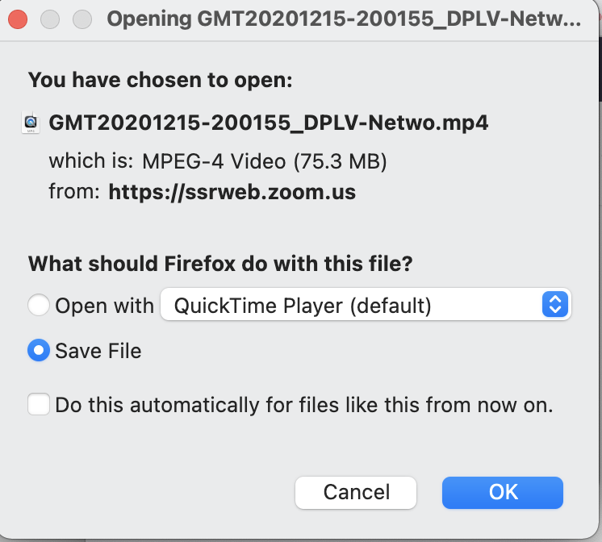
- If you would like to delete the recording after you’ve downloaded it to your device, click the trash icon that’s to the right of the ‘Copy shareable link’ button.
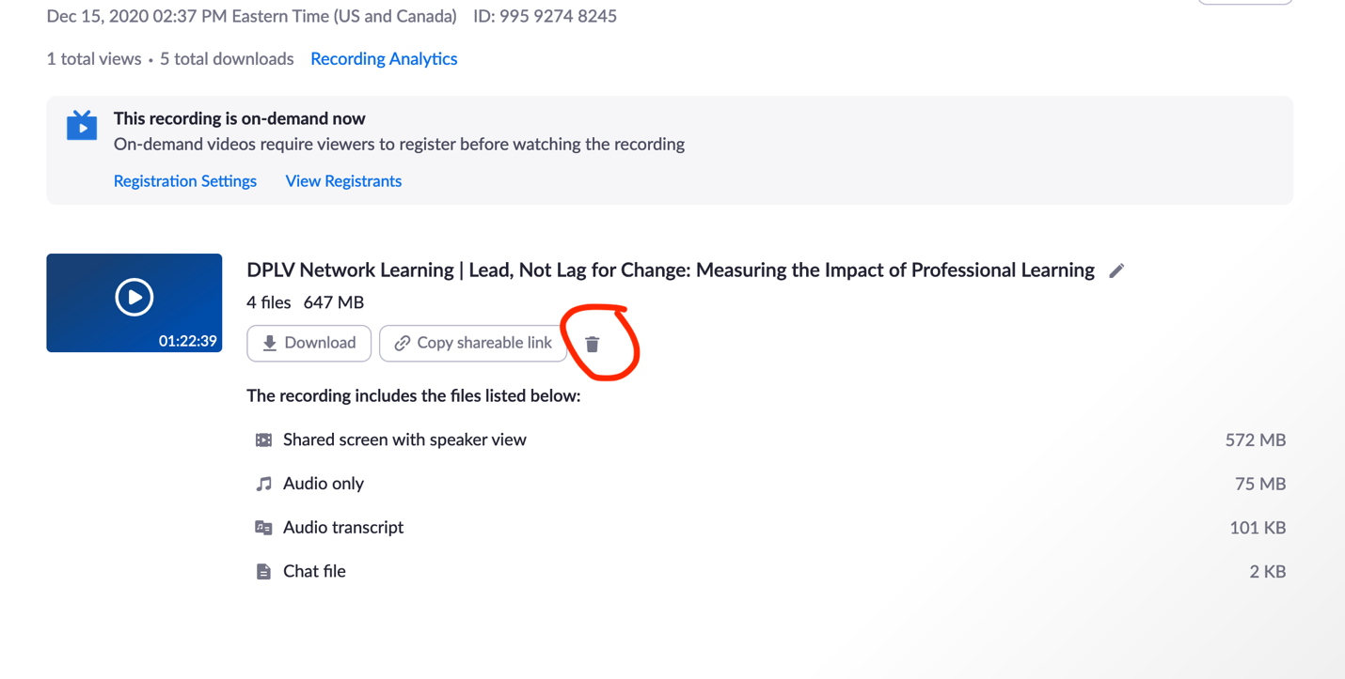
- Repeat the above steps for each recording you would like to download.

How to delete your recordings

- Follow steps 1-3 for “How to download your recordings to your device”
- Select the recordings you would like to delete (You can select all or one-by-one).
(Screenshot: Select one file)
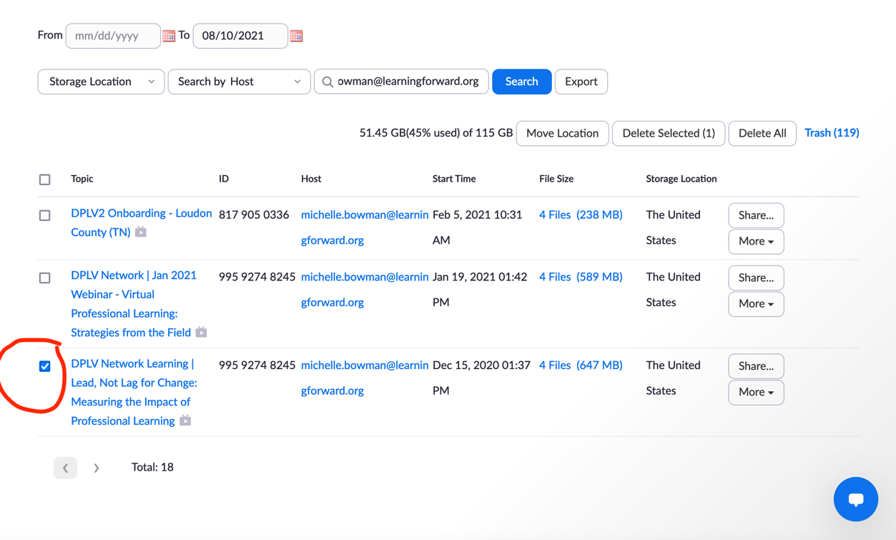

(Screenshot: Select all files)
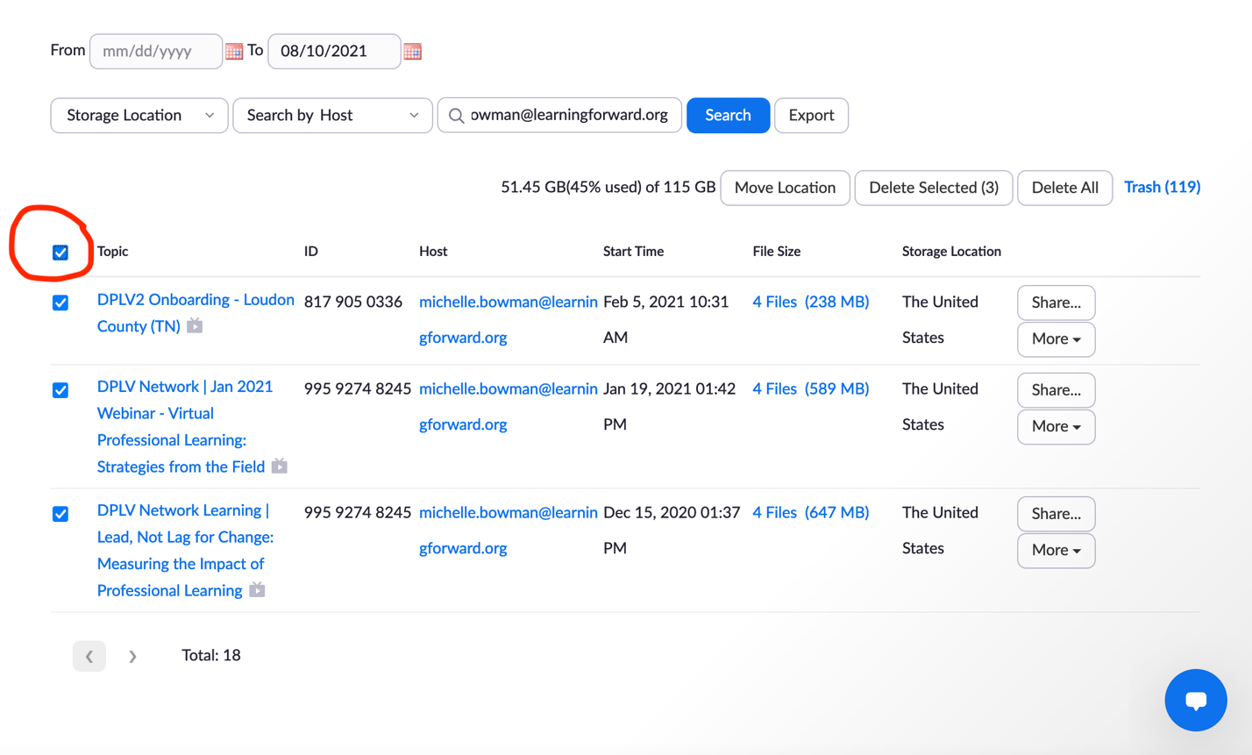

(Screenshot: Deleted selected files)
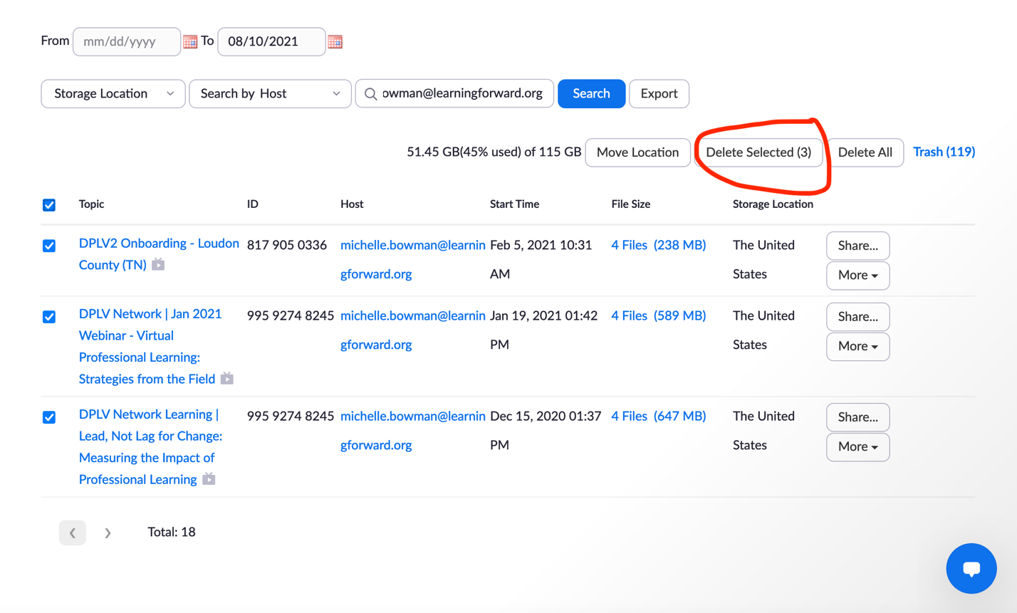

- A confirmation pop-up will appear, click ‘yes’ to confirm deletion.
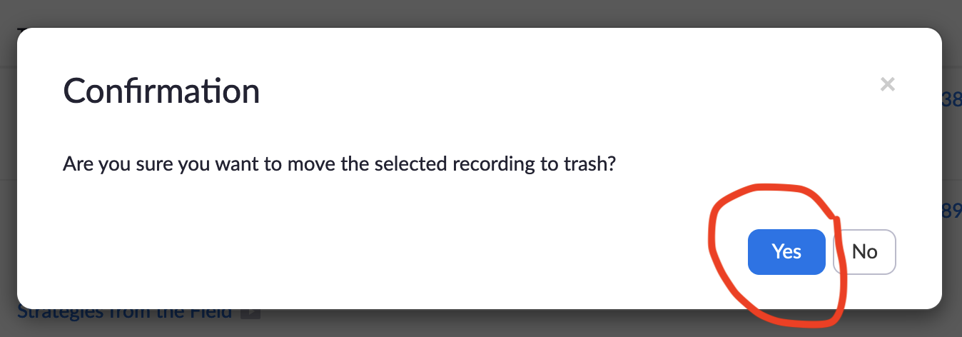

- After you confirm your deletion, the deleted recording(s) will be moved to the ‘Trash’ folder and the new storage allowance will be visible. The deleted files in the trash folder will not count as part of the total storage allowance. The deleted recording will remain in the trash folder for 30 days or until manually deleted permanently.
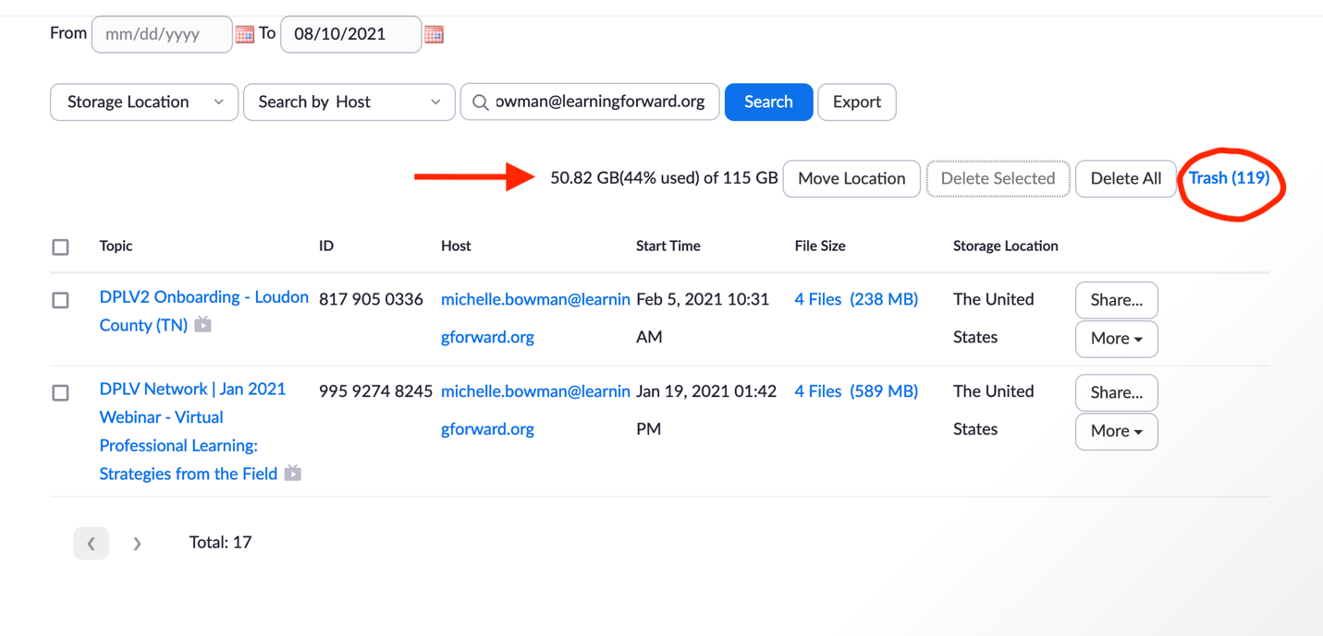

How to recover your deleted recordings

- Follow steps 1-3 for “How to download your recordings to your device.”
- Click on the ‘Trash’ hyperlink to view full list of deleted recordings.
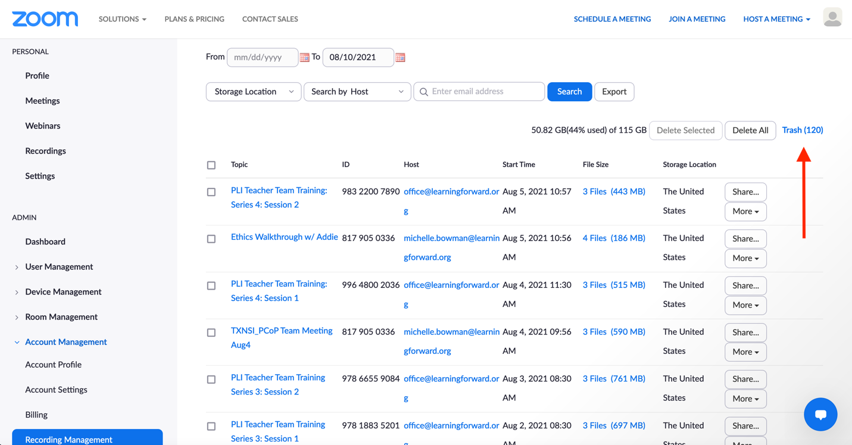

- You can browse the full list or filter to see only your recordings by adding your email address to the search box (click the search button afterwards to execute).
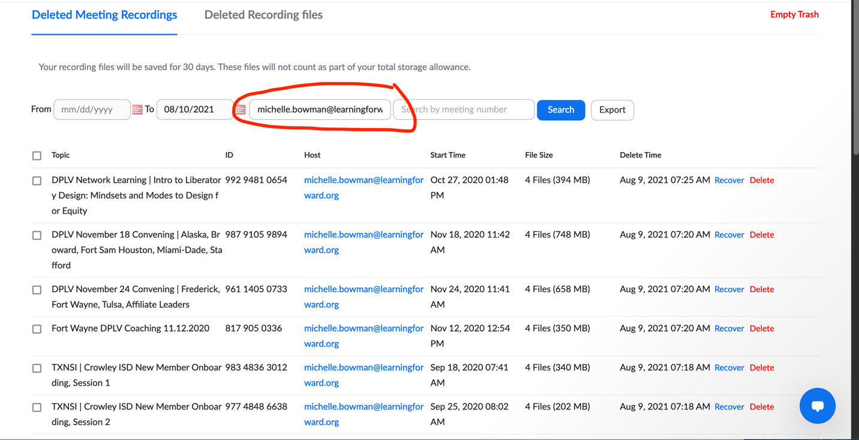
- You can recover individual files one-by-one by clicking the ‘recover’ hyperlink that’s to the right of every recording or you can select multiple recordings to recover.
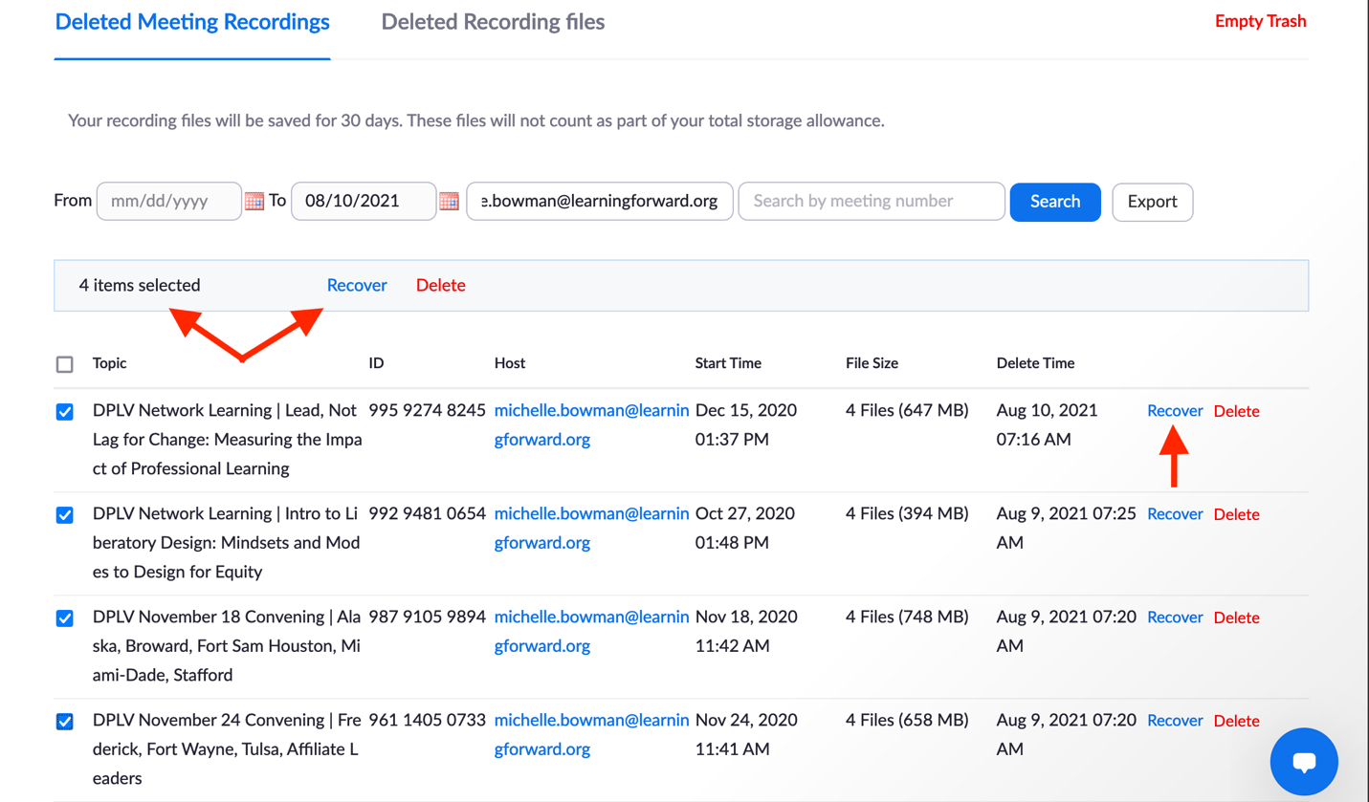

- After you click the ‘recover’ hyperlink a confirmation pop-up will appear. Click ‘recover’ if you want to continue forward with recovery of the recording.
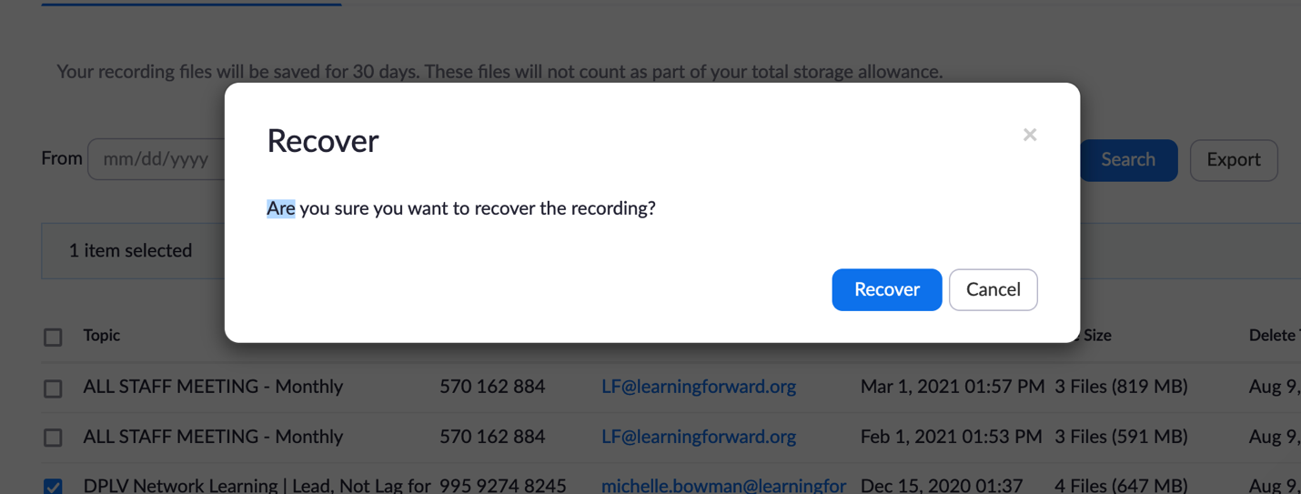

You will then see to the right of the recording that it is recovering. A green box will pop-up on the screen to notify you that the recording has been recovered.
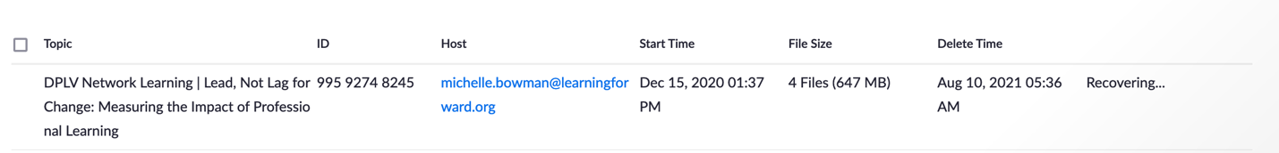

- Once the recording has been successfully recovered, you can then return to ‘Recording management’ where the file will be available to download. (Follow the ‘How to download your recordings to your device’ for instructions.)

How to move your recordings to Dropbox

- After you’ve downloaded your Zoom recording and saved it to your device, you’re going to sign into your Dropbox account.

- Create a new folder to store your Zoom recordings. (Decide if this is a private folder or a shared folder. If it is a shared folder, it will be visible by all Learning Forward staff members.)
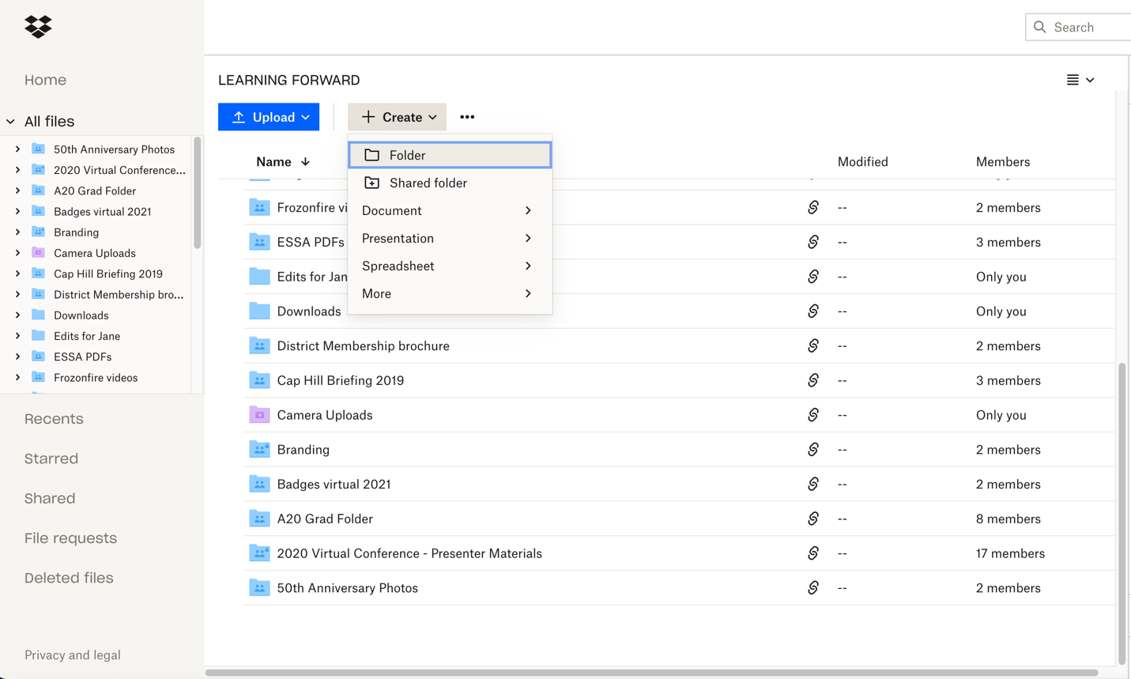

- Name the folder (e.g. “My Zoom recordings”; “Standards meetings”; “DPLV Cohort 1 Learning”) and identify who can access the folder.
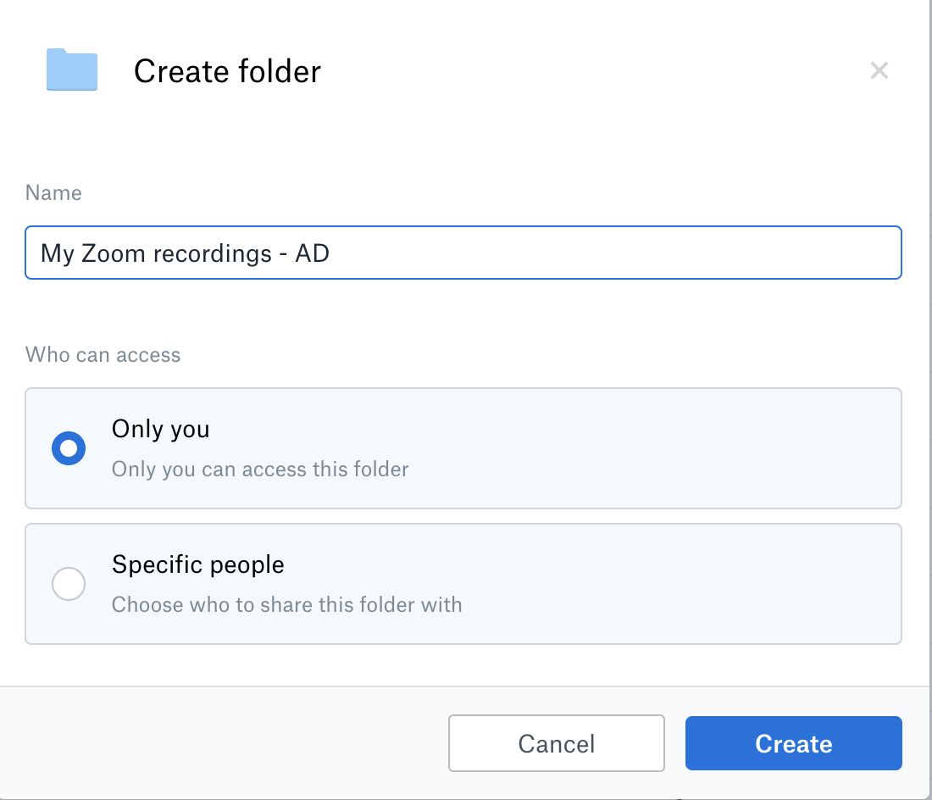

- In the designated folder for your Zoom recordings, click ‘Upload’ and select ‘Files’ or ‘Folders’ depending on how you saved your recordings (whether they are in a folder or not).

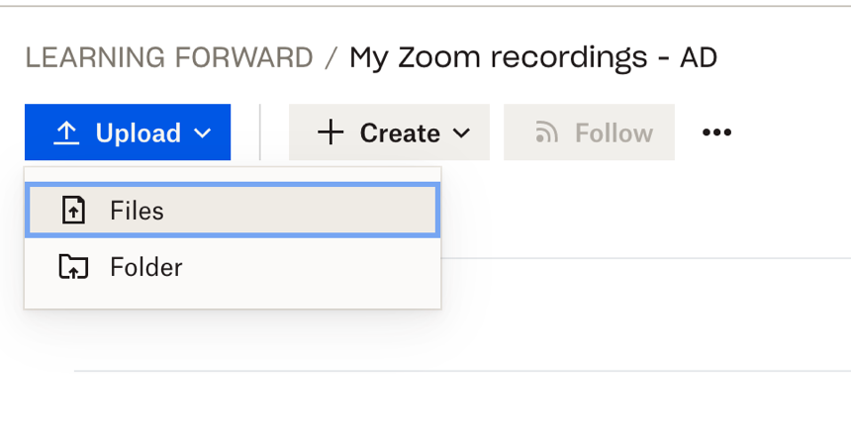
- Select the recording files you would like to upload to Dropbox. (You can also drag-and-drop the files to upload them to Dropbox)
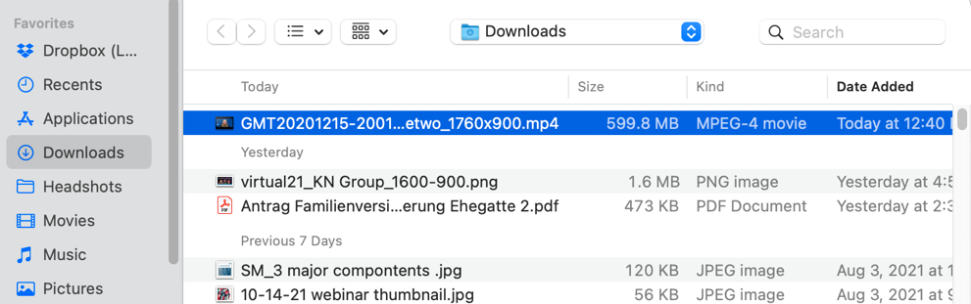

- The upload process will begin. The time it takes to upload the file(s) depends on the size of the file(s) and your internet connection.

- Once the file is finished uploading, the progress bar will say ‘Uploaded’ and you should see the file appear in your folder (you may have to refresh your screen to see the file in folder).

How to share recordings on Dropbox

- In Dropbox, you can share a folder and an individual file. To share your folder of Zoom recordings, click on the ‘Share’ button or the ‘link’ icon.
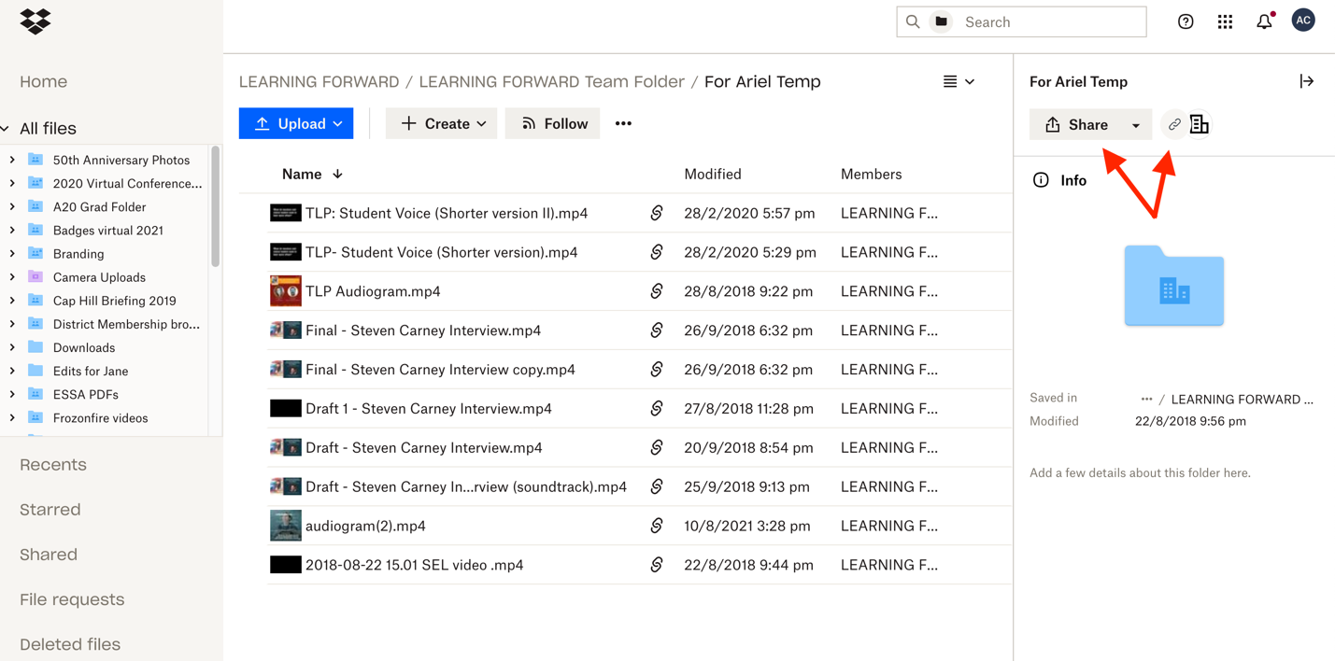

To share an individual file/recording, click the ‘link’ icon that’s to the right of the file name or click the three dots that represent ‘more’.
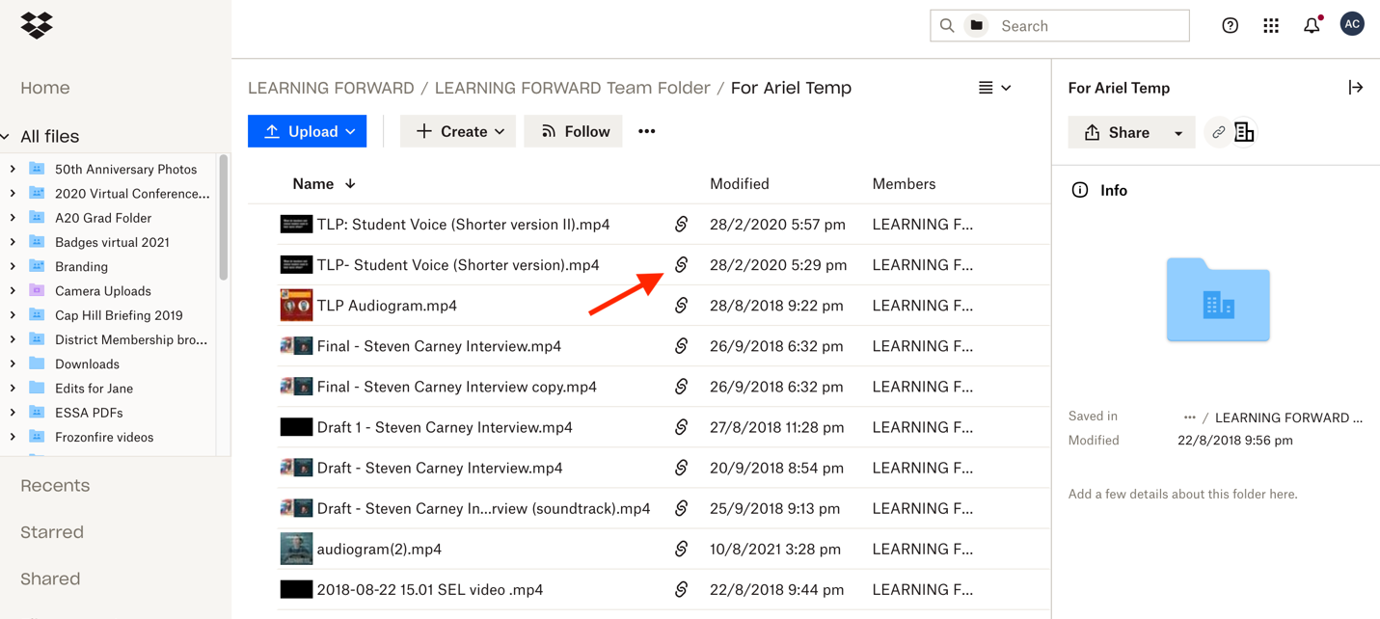

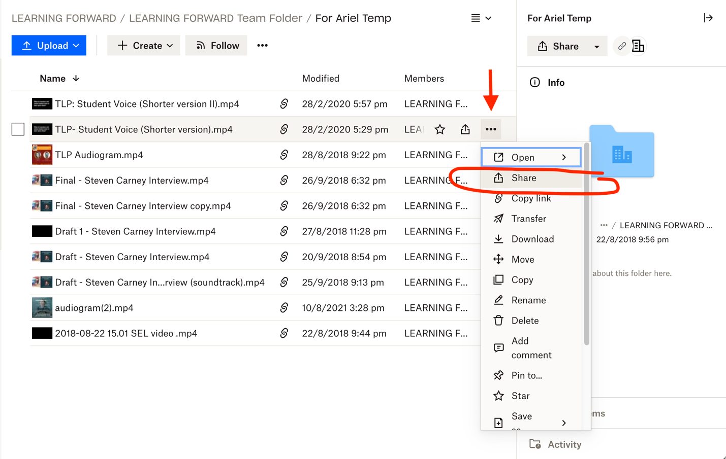

- After you click the ‘share’ button or ‘link’ icon, you can edit the link settings or simply copy the link.

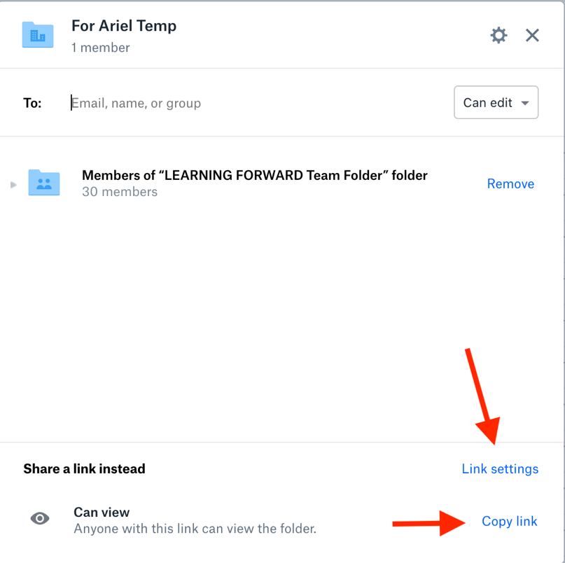
In the link settings, you can control who can view the file with the link, if/when the link expires, and if people with the link can download the recording file. You can also unshare the file at any time.

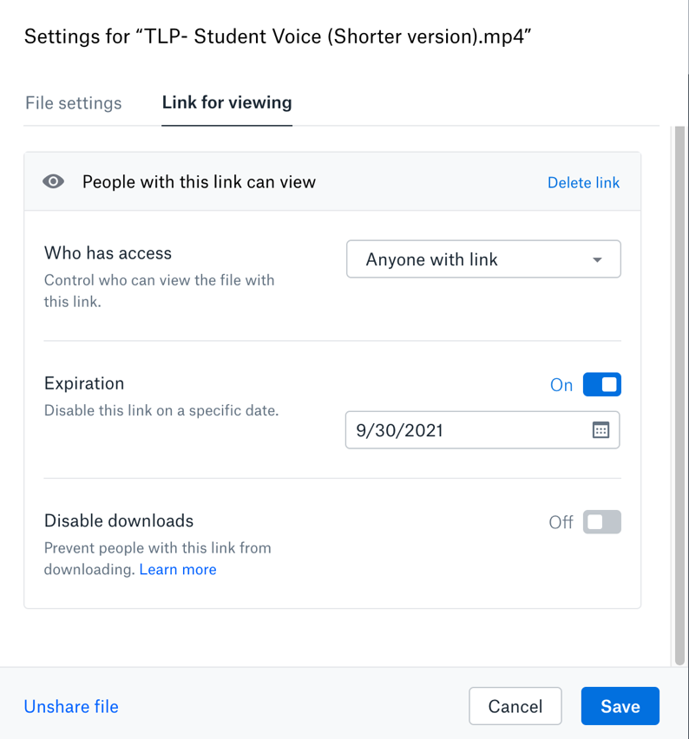
- After you’ve copied the share link, you can paste it where you like and send to whom you like.

