Shared Purpose: Parties entering into this agreement share the following vision and beliefs:
Learning Forward and Design Professional Learning in a Virtual World (DPLV) partners share a common vision to ensure excellence and equity in teaching and learning. All participants in the network are focused on ensuring that student learning continues as they themselves adapt to online, remote or hybrid learning, capturing lessons learned from the emergency shift to inform the improvement of professional learning utilizing virtual and digital-mediated educational models, and addressing current challenges related to the design, implementation, and measurement of professional learning in virtual and digital models.

Core Beliefs:
- Professional learning that improves educator effectiveness is fundamental to student learning.
- All educators have an obligation to improve their practice.
- More students achieve when educators assume collective responsibility for student learning.
- Successful leaders create and sustain a culture of learning.
- Effective school systems commit to continuous improvement for all adults and students.

Shared Benefits: This collaborative effort will lead to the following outcomes:
- A contextualized, comprehensive professional learning plan focused on outcomes
- Sustainable solutions for your district’s immediate challenges and for a professional learning infrastructure that transcends COVID Solutions aligned to district and state strategic plans that work across departments
- Increased capacity to create policies and practices for effective professional learning
- Access to professional learning tools and resources aligned to the Learning Forward Standards for Professional Learning. Collaboration and critical-friend relationships with leaders from like-minded districts
- Understanding of how short-term COVID lessons can inform long-term professional learning plans
- Professional learning that is focused on equity through innovative strategies

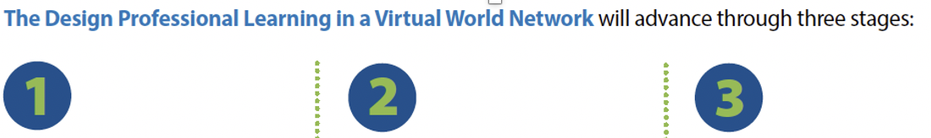
Support ongoing success in virtual and hybrid learning environments | Respond, recover, and maximize learning during each school year. | Reinvent professional learning to acknowledge and embrace new learning models

Included:
- Development of an ongoing professional learning plan for the district/state
- Integrated needs assessment at each stage including 1:1 interviews, focus groups, and survey instruments
- Support to compile data and share with the district/state team to inform professional learning planning
- Facilitated team and network time for learning and design
- Virtual engagement and access to resources through an online community
- Opportunity to be featured in Learning Forward communications and publications
- Comprehensive Learning Forward memberships for team members

Cadence
- Onboarding and at least monthly virtual call with a Learning Forward coach for:
  - Ongoing technical assistance and consultation to review needs assessment
  - Development of district professional learning plan using Learning Forward standards, tools and resources
- Facilitated professional learning related to outcomes aligned to focus areas
- Quarterly virtual, facilitated team and peer-to-peer check-ins
- Quarterly webinars featuring thought leaders tied to network challenges
- Three one-day virtual network convenings
- Dedicated team planning time with facilitator support

Membership Fee:
$19,500 annual membership fee for a team of 4-5 director-level administrators responsible for professional learning, academics, technology integration, assessment, and leadership. Teams will be encouraged to bridge silos and model collaboration.

Contact Information
LEA/SEA Name:
No abbreviations
Commissioner/ Superintendent:
County:
State/Province:
Total # Students:
Total # of Teachers:
Professional Development budget (annually):
Contact Name:
Contact Job Title:
Contact Email:
Contact Phone:
Mailing Address:

Application Questions
- Describe how the goals of DPLV align with your priorities and goals.

- What other major initiatives (e.g. interventions, consultants or programs) are underway in the district/state, specifically related to professional learning, including curriculum-based professional learning?

- How does the district/state ensure that every educator engages in effective professional learning?

- How does the district/state ensure that decisions made at levels ensure both a coherent and relevant learning experience for teachers that improves their practice?

- How does the district/state currently collect evidence/data to evaluate the impact of professional learning? How often does this occur? Who is responsible for data collection and analysis?

- Who will make up your team?
Please include a list of who would participate from your district/state, including name, job title, and campus (if applicable) for each participant. Include reasoning for each participant.
The ideal team consists of 4-5 director-level administrators responsible for professional learning, academics, technology integration, assessment, and leadership. The professional learning leadership team (core team) leads, authorizes, and deeply engages in the continuous improvement process: testing and implementing change ideas, gathering and analyzing data, and making decisions that lead to dramatic progress on the problem of practice in the system.

- How are major agency initiatives communicated? How do you measure the extent to which stakeholders buy into initiatives?

- Please explain what supports will be put in place to enable your staff to participate. Note: attendance and active participation in all convenings and activities are essential to community health.

Signature:
Note: Electronic signatures are accepted

