Dr. Sheila Barrett McCabe

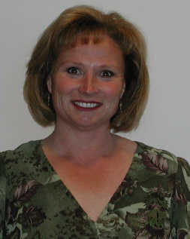
Dr. Sheila Barrett McCabe is the Assistant Superintendent of Educational Services in the Fairfield-Suisun Unified School District. Serving over 21,500 students, the District is home to a myriad of high caliber educational opportunities.

Dr. McCabe has served in the District for eleven years. During her tenure the district has expanded the number of educational options available to families, to include opening the Public Safety Academy, Early College High School program at Solano College, and the Virtual Academy of Fairfield-Suisun.

An area of focus for Dr. McCabe has been to develop authentic community partnership. This work has resulted in the Inspire: Dreams Start Now interactive career fair for 8th graders and the Inspire: Dreams Move Forward industry tours for 10th graders. The program has been so successful that it expanded to four school districts in Solano County, as well as to two other neighboring counties. To date, over 13,500 students have participated in the 8th grade program and nearly 2,500 students have participated in the 10th grade program. In 2018, Dr. McCabe was recognized by the Fairfield-Suisun Chamber of Commerce for her contributions to the business community.

Dr. McCabe is Past-President of the Rotary Club of Cordelia. During her year as President, she co-chaired the committee that oversaw Rotary’s Teen Cultural Arts District Grant. Dr. McCabe is a member of the Solano Economic Development Corporation’s Board of Directors and the Fairfield Community Services Foundation Board.

Dr. McCabe holds a Doctorate from University of Southern California, Masters from Pepperdine University, and Bachelors from University of California at Davis. She and her husband, Lloyd, are currently residents of Dixon. They are involved in many community activities, including “Grillin and Chillin” and the Dixon May Fair. In her spare time, Dr. McCabe loves to scuba dive and read.

