Adapting high-quality instructional materials for
a virtual teaching context
May 7, 2020

Link to slides: https://learningforward.org/wp-content/uploads/2020/05/Webinar_5-7-20__FINAL.pdf

Twitter handles for the panelists:

- Emily Freitag @EBFreitag
- Kaitlyn Billops @kaitlyn_billops
- Taylor White @MissWhite207
- Jana Beth Francis @JanaBethFrancis

Resources and links from the panelists:

From Emily Freitag
- Six weeks of instructional materials
- Aspirations for student culture and learning
- www.edreports.org

From Kaitlyn Billops
- Daily lesson plan samples

From Taylor White
- Video samples

Learning Forward resources:
- COVID-19 online resource page
- COVID-19 online community
- COVID-19 webinars

Poll Questions & Results (next page)

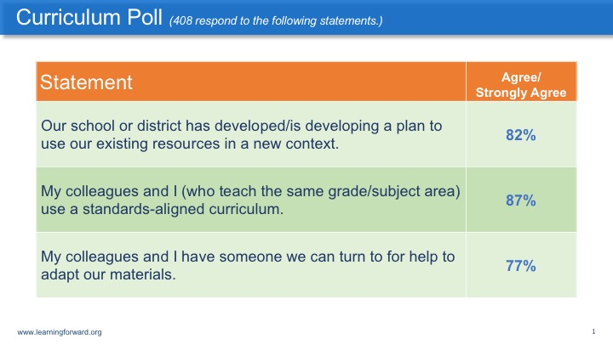

Participants’ suggestions:

- Free Text: https://time.com/tfk-free/
- https://pioneervalleybooks.com/pages/literacy-footprints-digital-reader
- Have you guys thought of utilizing Google classroom? At my school, we've utilized Google Forms instead of packets since Google Forms can auto grade some of the simpler questions as well as give valuable consolidated feedback to the teacher. It can embed pictures, videos, do file upload questions (great for students to upload a PowerPoint for credit) etc. and utilizes different question types. Plus it can put everything conveniently in one spot in Google drive :).
- You can have polls and questions to answer in virtual learning environments that offer feedback on student engagement.
- We are seeing lots of use of google classrooms and schoology.
- If you have an audio component, especially for the text complexity of secondary, it supports the EL, IEP, and striving reader. They can listen as often as needed; pause for the Think-Aloud as in regular classroom; read aloud having the audio correct them.
- Careful not to lose discovery/inquiry based constructivist approach and the student's thinking not just answer. I am specifically talking about mathematics.
- Get More Math offers a strong spiral program, and it's free through July 2021: www.GetMoreMath.com
- Breakout sessions on internet conference platform! Kids need to record it so we can see what they discussed.
- Math Learning Center has great apps that can be used.
- Our high school uses All in Learning for online assessments.
- This has been super helpful for math! http://www.glencoe.com/sites/common_assets/mathematics/ebook_assets/vmf/VMF-Interface.html
- I didn’t get to try it, but there is an app called Floop EDU where teachers can upload assignments and kids take pictures of their work in progress. Then, the teacher can drop a pin on particular parts of the assignment and leave feedback. The idea is that they are giving ongoing feedback while the student is working through the assignment.
- My building is PreK-2. We use See Saw a ton and have had much success.
- In DCPS, we have created resources aligned to our analog curriculum. DC Public Schools Instructional Continuity Resources: https://dcps.instructure.com/courses/179580

Participants’ responses to panelists’ comments and strategies:

- I agree about the SINGLE digital platform!
- Autonomous learners! I find myself teaching my kids how to learn, rather than the math content they so desperately need....
- I love the point about feedback to students. It is so important and it is central to deeper engagement. Intentional, personal feedback is lacking for my 14 yr old. As an educator, I am sad that he doesn't get feedback, just that check mark of completion.
- There is inequity between Buildings and PLC's within each individual building whether educators have support.
- I work with nonverbal medically fragile students. Online teaching is very challenging.
- Yes! It’s so important to consider the ways we engage parents as partners!
- Content Selection is so important. Essential standards only and being explicit--totally agree.
- Teachers need to understand the learning intentions then the success criteria to achieve the intention.
- We have measuring evidence of their attempt at the lesson whether the responses were correct or incorrect-no grading.
- I agree we have to engage our parents regardless of where their educational background stands.
- You are spot on with the challenges in math.
- Wouldn't it be a wonderful thing if that notion of collaborative problem-solving wasn't just a "math thing".
- I would say fortunately there is not an emphasis on grading at this time, it is about the learning.
- We’re having the same conversations in science classes, with the same challenges.
- Students as LEADERS of their own LEARNING.
- We’re not giving quizzes on All in Learning now, but our school will be using it in the future. The students do not know the program right now and the teachers are just learning it now.
- Assessment AS learning.
- I wonder if we need to take a closer look at writing across the curriculum. If we had a greater focus about writing about your learning, students might be able to better demonstrate their knowledge and understanding through their written response.
- Often the school will dictate what types of assessments the teachers must use.
- This assessment capable learners and competency measuring is easier for parents to understand and support as well.
- Strong opinion here- there's no point or place for summative assessment at this time (for so many reasons). Assessment should be formative in nature and include vibrant, individualized feedback.
- Wellness checks are so ESSENTIAL!
- My “scholars” - love that!!
- I love the term scholars, Teach Like a Champion verbiage! I use that.
- I love the use of the word "scholars." High expectations!
- Truly believe all assessment should move towards no fail and build each student's agency in their learning journey leading to their futures.
- Babies AND Scholars….gotta love it.
- I sincerely hope that specific instructional training for teachers will be implanted! Concise and coherent instruction for us non-technology instructional learners! I for one need that!
- Now is the time for "Just in time" professional learning.
- Yes Emily, our teachers need that PD as we go, targeted support! I support beginning teachers and this type of asynchronous PD is needed!
- One final thought is how important it is we examine our mindsets and our ideas about best practices for intervention.
- In our province we are focusing on assessment FOR and AS learning, rather than evaluation (or assessment OF learning)… lots of descriptive feedback right now. :)
- We have been working to help leaders, coaches, & peers who need support in how to provide feedback to teachers in the new models—how to determine if and how/why students are learning.

