Learning from coaches: Supporting educators in a virtual world
April 23, 2020
Chat box dialogue

Link to slides: https://bit.ly/2KvErVP

Contact information for the panelists:

- Joellen Killion Joellen.killion@learningforward.org
- Ebony Flott Ebony.Flott@gcpsk12.org
- Courtney Simpson Courtney.Simpson@gcpsk12.org
- Melissa Cournia Melissa_cournia@bismarckschools.org

Resources and links from the panelists:

From Joellen Killion
- Outcomes-focused coaching map

From Melissa Cournia
- Tools: Implement new learning

Learning Forward resources:
- COVID-19 online resource page
- COVID-19 online community
- COVID-19 webinars

Poll Questions & Results
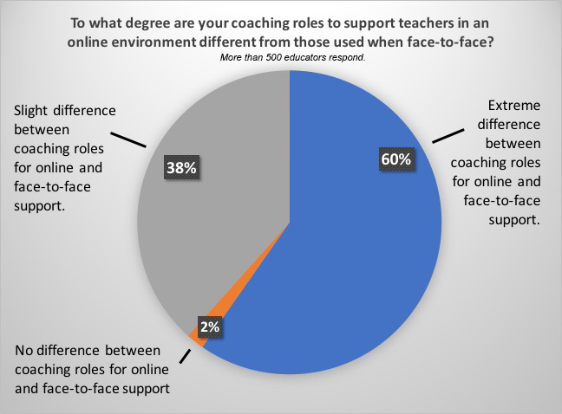

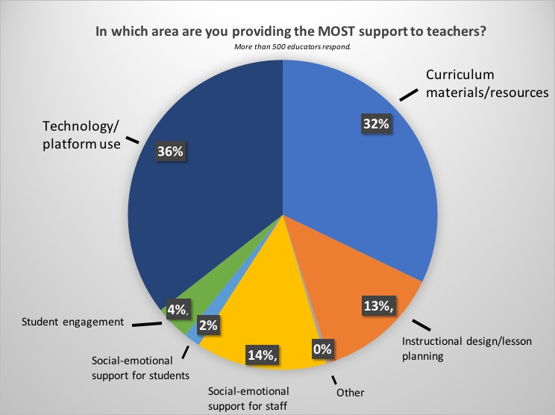

Participants’ suggestions and comments about coaching:
- Listening is the skill behind it all. It will certainly direct intentions!
- Train coaches in school systems, admin and teachers.
- Modeling listening to teachers.... helps teachers realize how important it is for them to listen to their students.
- Identifying the patterns has really helped us plan from week to week.
- Peer-to-peer digital mentors...brilliant!
- We also provide webinars (office hours) and feature teachers from the district who want to share ideas. We also have a 3 day a week office hours for our coaches and parents who want to ask questions or voice concerns. So far this has been effective.
- Quality feedback is KEY!
- “Be vulnerable.”
- So one thing I have done is I created a Google Calender with appointment times and they have the control to set up an appointment with me to meet in email, phone, text, or Google Meet.
- Here is our online resource document we have been using since March as we transitioned to online learning: https://docs.google.com/document/d/1mPbumTImBnet6lvXWG9x3P5DvGFRTdyFg6qg3zeBVCU/edit?usp=sharing
- We have created a top five instructional resources/sites for each content area.
- Brene Brown has a FANTASTIC podcast on what she has called FFT's-- all of our teachers listened to it and it has helped us focus on the fact this this is all new and we all need grace.
- Brene Brown has a good YouTube video introducing Dare to Lead too.
- I also recommend Brene Brown's The Gifts of Imperfection.
- Teachers have invited me to join their Google Classrooms and Google Meets with their students. Lots to debrief after! So glad to have knowledge of their students from previous class visits.
- I love this Vulnerability poem from David Whyte too: https://onbeing.org/blog/vulnerability/
- We are pointing teachers only to technology we have been using already, nothing new. Textbook resources plus Khan which we’ve used throughout our district, and any other platforms that we’ve paid for and trained on.
- I have seen a lot of teachers providing an extended amount of time to do the work which is really helpful. We have students whose circumstances don’t permit synchronous learning.
- Yes, asset focused questions instead of deficit focused questions. These open the door for us as teachers to think about what we need.

Participants’ responses to panelists’ comments and strategies:

- Assessment and Evaluation is a big stressor for teachers during this time... getting LOTS of anxiety-ridden Qs about that!
- My assistant principal has been saying "Grace over Grades".
- Listening and grace is so important at this time.
- Love Melissa's emphasis on listening...feels so critical for accessing what's needed.
- "Listening for the silences and the patterns."
- Agree on the power of listening for patterns.
- Love the team approach, not silos.
- Yes, I agree that GRACE is the emphasis here, at this time. Teachers and other folks who are invested in students need to give grace to all involved.
- Thank you, Melissa! Listen, find the patterns and lots of grace!
- I love “simple”.
- We love Michelle. Lead with heart, then head. Powerful ways to equip staff in a hear forward way.
- Love this idea of webinars for teachers as a menu of learning and support.
- Love that--digital mentor.
- I love the idea of a digital mentor and all tech in one place for access.
- I think GRACE and balance are so important for all. Allison McAtlin Grand Junction Colorado Learning Model Coach in two elementary schools.
- This is a great tool for teachers to have access to webinars.
- Thanks for the reminder to use Screencastify. I’ve been mulling between that and Flipgrid.
- Our District is about Relationships, Grace, Patience, and Love.
- So true!! Good teaching is good teaching.
- #allmeansall Love it!
- I love the digital teacher to teacher support.
- LBUSD also distributed Chromebooks to all students who needed it, partnered with the city to get internet to homes that didn’t have it, and opened a parent/student helpline to assist.
- Internet hot spots added to school buses who are going into neighborhoods to deliver daily lunches.
- Our school’s focus this year has been to give one another space and grace!
- I agree on the partnering a zoom and one person monitoring the chat box. I do that when presenting to adults, it's important for the flow.
- I was a Special Education Teacher for 20 years, K-8 grades. This is my first year as a Special Education Coach! I love it! It has definitely been a year of learning!
- This is very well done; you all are hitting the nail on the head. No catfish webinar here lol, it’s giving me exactly what the title says it would!
- This has been the BEST webinar I have attended in the last several weeks (there have been MANY!). I am walking away with pages of ideas-- thank you!!
- This is one of the most helpful and meaningful webinars I have attended. Thank you to all panelists and attendees for making this so worthwhile to attend. I am excited to hear and share new ideas I have gained.
- Very helpful webinar. I am a new coach this year and now I am learning to coach virtually too. This has been very helpful!

