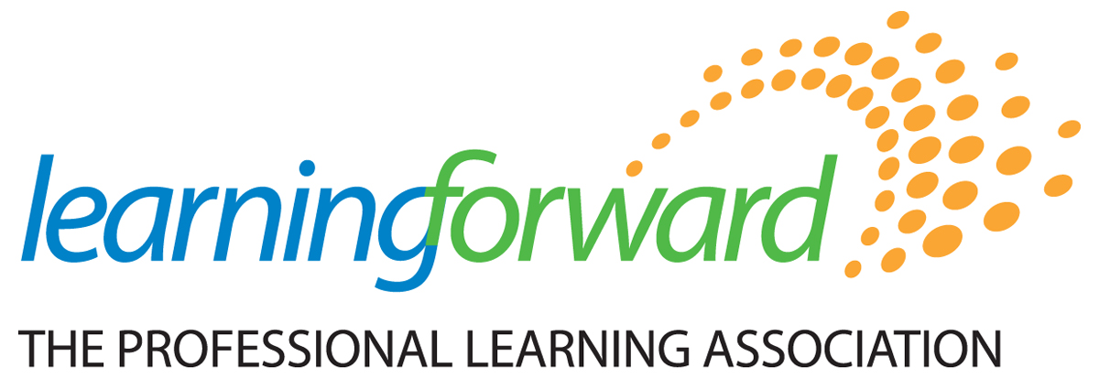

Board of Trustees Election 2019 BALLOT

Please select between one and four of the following candidates to ratify the selection of the candidate as a member of the Learning Forward Board of Trustees to become effective December 12, 2019.
Your member number MUST be included for this ballot to be valid: _________________

Candidates:
______ Mark Elgart, Alpharetta, Georgia
______ Segun Eubanks, College Park, Maryland
______ Sue Sarber, Arlington, Virginia
______ Ash Vasudeva, Stanford, California
Write-in: ______________________________
Date submitted: ________________________________________

Submit by fax to: 972-421-0899 – ATTN: Joel Reynolds
Submit by scan/email to: joel.reynolds@learningforward.org
Submit by mail to: Joel Reynolds
Learning Forward
17330 Preston Road, Suite 106-D
Dallas, TX 75252-6036

